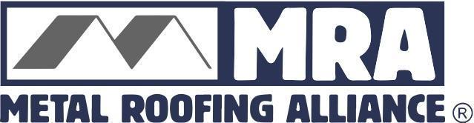

Contact: Darcie Meihoff, Metal Roofing Alliance (MRA), darcie@metalroofing.com or 971-998-3782

FOR IMMEDIATE RELEASE
September 8, 2021

2020 DODGE ROOFING INDUSTRY REPORT SHOWS INCREASE IN METAL ROOFING USE FOR U.S. RESIDENTIAL RE-ROOFING MARKET
PORTLAND, Ore.–The numbers are in and it’s good news for metal roofing. More homeowners are choosing sustainable, resilient metal for their re-roofing projects, according the latest 2020 Dodge Report that measures overall roofing demand and activity on an annual basis. The report reveals that the share of metal roofing used for residential re-roofing in the U.S. rose from 12 percent in 2019 to 15 percent in 2020.
“There’s no doubt homeowners are getting the message: Durable, stronger and longer-lasting quality materials are a much better investment for your home over the long run, especially in light of climate extremes,” said Renee Ramey, executive director of the Metal Roofing Alliance (MRA). “That mindset is reflected in the latest numbers and overall growth of the metal roofing industry.”
The Dodge Report also reveals that while traditional metal roofing styles such as standing seam remain popular, homeowners also are gravitating to the wide variety of designs that metal roofing offers, including shingle, shake, tile and slate. Steel remains the most common type of metal roofing for re-roofing projects, due in part to its affordability and strength. Like other metal alloys, steel also increases energy efficiency and can be 100 percent recycled at the end of its long life, making it a sustainable and better performing choice for even the harshest climate conditions, including high winds and hail, heavy snow and ice loads.
Importantly, the adoption of metal roofing rose in regions that suffered severe impacts from climate extremes in recent years, including the Mountain and Atlantic areas. Hurricanes and wildfires have intensified in those regions and affected more homeowners, causing them to gravitate towards resilient and protective products that can help better safeguard their homes. Quality metal roofs, which carry the highest possible Class A fire rating and can withstand hurricane force winds, are an essential component in fortifying homes against the worst that Mother Nature can throw at them.
While not measured by the Dodge Report, the MRA also theorizes that homeowners are increasingly attracted to metal roofing’s low maintenance and easy care benefits, based on the organization’s own data and web site that receives hundreds of thousands of visits from homeowners looking to learn more about metal roofing every year.
“It’s clear homeowners don’t need one more thing in their lives to worry about, and the fact that metal is exceptionally easy to care for and will outlast other types of materials while offering great peace of mind is undoubtedly a very strong selling point these days,” said Ramey.
About Metal Roofing Alliance (MRA)
Representing the residential metal roofing industry in the United States and Canada, the Metal Roofing Alliance (MRA) was formed to help educate consumers about the many benefits of metal roofing. The main objective of MRA is to increase awareness of the beauty, durability, and money-saving advantages of quality metal roofing among homeowners, as well as to provide support to the residential metal roofing industry. For more information, visit MRA at www.metalroofing.com.
# # # #

