California cool…from top to bottom
NEW METAL ROOF A CROWNING TOUCH FOR LOVELY VENTURA LOFT PROJECT

The Project:
A quality new construction build deserves a quality roof. For a beautiful new multi-family loft project located near the sunny shores of Ventura, California, deciding on a metal roof boiled down to style, sustainability and long-term performance. The result: A strikingly modern spin that achieved everything the contracting group–and the building’s residents–look for when it comes to exceptional design, comfort and livability.

The Challenge:
Completed in January 2021, Ventura Garden Lofts are the very definition of California cool, capturing an industrial style complete with a modern beach villa feel thanks to the use of metal not only for the roof, but the exterior of the lofts. And because the units are located on the coast, quality metal with a high-performing coating was an absolute must. That’s why an ATAS manufactured aluminum alloy with an extremely durable Kynar finish was selected by The Becker Group, Inc., the contracting group for the project. As a new construction project, deciding on a quality metal roof was a true investment in the future, resulting in much greater energy efficiency while reducing the wear and tear caused by the region’s coastal conditions and the need for replacement. The use of metal helps reduce a variety of impacts on the planet, given metal is much more resilient against climate and weather extremes and can be recycled at the end of its very long life.

Spotlight on MRA members ATAS International and Howard & Sons, Inc.: Guided by installer Howard & Sons, Inc., The Becker Group, Inc. chose ATAS International .32 Aluminum 37 1/4" Corrugated Panels in Charcoal Gray and .32 Aluminum 37 1/4" Corrugated Panels in Silversmith. The contrasting colors created a stylish, sleek look and given the Kynar finish, the material is exceptionally durable and will help save energy.

Howard & Sons, Inc. completed the project in just seven months, which was made all that much more complex given the need for many additional penetrations. Since metal was used on both the roof and walls, the addition of canopies and lights caused there to be more penetrations than just a normal roof. Thanks to their installation expertise, the project exceeded all expectations and will add outstanding architectural value as part of the community for many years to come.

Thoughts from the contracting group and installer: “It was amazing to work with the Howard & Sons team. From the beginning to the end, from color choices and design to production, they were super easy to work with and we are looking forward to this roof continuing to look great for years to come.” – Hutton Becker, The Becker Group, Inc.

“The Becker Group made this one of the best new construction projects we have ever worked on. They had amazing communication and were extremely flexible, making it easy for us to do our job efficiently and expertly.” – Dustyn Howard, Howard & Sons, Inc.

For more about MRA members Howard & Sons, Inc. and ATAS Metal:
MRA Manufacturer Member: ATAS International, Inc. https://www.atas.com/
MRA Installer Member: Howard & Sons, Inc. www.hnsca.com
About Metal Roofing Alliance (MRA)
Representing the residential metal roofing industry in the United States and Canada, the Metal Roofing Alliance (MRA) was formed to help educate consumers about the many benefits of metal roofing. The main objective of MRA is to increase awareness of the beauty, durability and money-saving advantages of quality metal roofing among homeowners, as well as to provide support to the residential metal roofing industry. For more information, visit MRA at www.metalroofing.com.

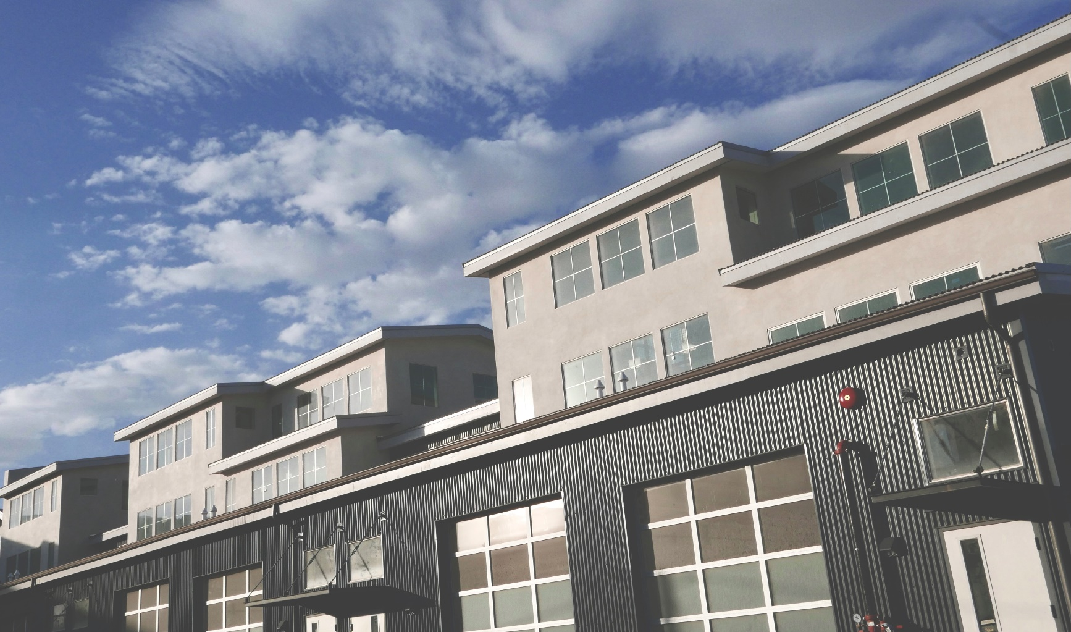
(Photo courtesy of Johannah Fitzgerald from The Becker Group, Inc.)

