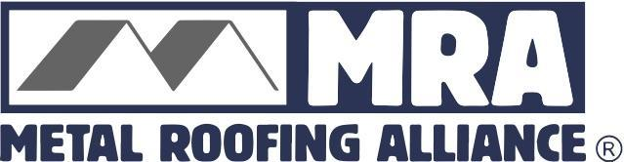
For high-res images and additional information, contact: Darcie Meihoff, Metal Roofing Alliance (MRA), darcie@metalroofing.com or 971-998-3782

FOR IMMEDIATE RELEASE
July 16, 2021

DISTINCTIVE METAL ROOFING IN OHIO TAKES TOP HONORS IN MRA’S BEST RESIDENTIAL METAL ROOFING PROJECT COMPETITION

PORTLAND, Ore.—The Metal Roofing Alliance (MRA) has selected Distinctive Metal Roofing based in Ohio and Pennsylvania as the second quarter winner of its Best Residential Metal Roofing Project competition.

Located in Oak Harbor, Ohio, the award-winning project features an installation of a beautiful new metal roof on a barn style, 1952 home that originally had a single layer asphalt roof. The complexity, design and long-term performance delivered by the new metal roof impressed the judges and it adds significantly to the home’s unique architectural style, given the unique roofline is a major feature. Distinctive Metal Roofing was able to install the quality new metal roof right over the top of the aged asphalt roof that was failing due to granular loss, streaking and had missing shingles and hip caps. Doing so helped prevent waste from ending up in the landfill and increases the energy efficiency of the roof.
“As their ‘forever’ home, the owners were looking for maximum long term reliability, performance and beauty,” said Bruce Hicks, Distinctive Metal Roofing. “Metal was the perfect choice and helps give the homeowners great peace of mind that they now have a worry-free, low maintenance roof that adds great curb appeal to the home.”

The new metal roof mimics shingles yet will last decades longer than other types of roofing materials. Due to the steepness of the sides and the silo, the Distinctive Metal Roofing team had to use a 60-foot articulating boom lift to obtain the best access in order to be able to install more than 55 squares of metal roofing material. In the end, that attention to detail and the beautiful result are the reasons this project was selected for MRA’s top honor for the second quarter of 2021.

With this phase of the competition now closed, the search is on for MRA’s final Best Residential Metal Roofing project for the third quarter of 2021. Open to U.S. and Canada homeowners, contractors, installers and manufacturers, MRA officials will select one outstanding metal roofing project based on project appearance, performance and originality/use of materials. Interested participants may upload their project photo along with a 200-word or less description for why their metal roofing project is worthy of top honors online at metalroofing.com. Next quarter’s winner will be announced in September, and only residential metal roofing projects in the U.S. and Canada will be considered.

For more information about how to enter MRA’s “Best Metal Roofing” competition for the trades, visit www.metalroofing.com
About Metal Roofing Alliance (MRA)
Representing metal roofing manufacturers in the United States and Canada, the Metal Roofing Alliance (MRA) was formed to help educate consumers about the many benefits of metal roofs. The main objective of MRA is to increase awareness of the beauty, durability and money-saving advantages of quality metal roofs among homeowners, as well as to provide support for metal roofing businesses and contractors. For more information, visit MRA.
# # # #
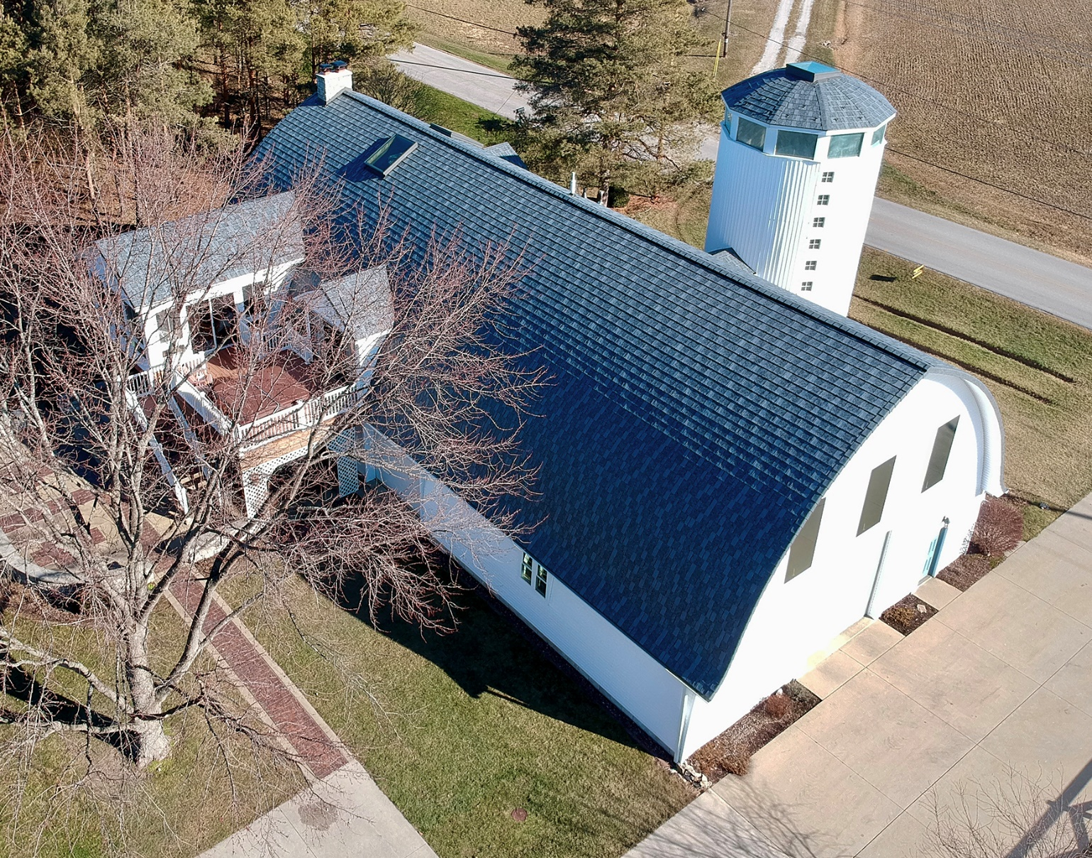
Suggested photo caption: Distinctive Metal Roofing in Oak Harbor, Ohio won the Metal Roofing Alliance’s Best Metal Roofing Project competition this quarter for a high-performing, stylish metal roof installed on an Oak Harbor, Ohio home

