Metal for honor: Building homes for heroes
WARRIOR VILLAGE PROJECT CONTINUES TO RAISE THE (METAL) ROOF FOR BRAVE VETERANS

The Project:
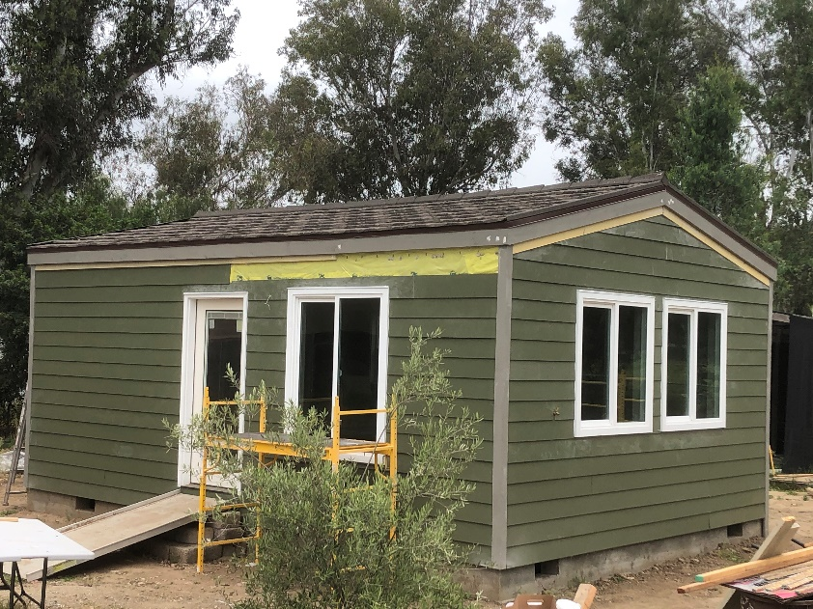
It is a very special project for some very special residents: Based in Fallbrook, Calif., the Warrior Village Project is building affordable, permanent housing for homeless U.S. veterans while training the next generation of home builders in the process. The nonprofit organization is currently building small cottages that will be installed as Accessory Dwelling Units (ADUs or ‘Granny Flats’). The ultimate goal is to build enough compact, highly efficient homes to populate one or more pocket neighborhood cottage communities designed to house local San Diego County veterans in need. Most recently, veterans teamed up with former and current students from San Marcos High School to help out on two Saturday Work Days in Vista to build a much-needed home.

The Challenge:
The Warrior Village Project brings together students interested in learning the building trades and industry associations, businesses and private sponsors, and volunteers, all for the extraordinarily good cause of building cottages to address the urgent need of providing housing for homeless veterans. Under normal circumstances, and with a very tight operating budget, this would be challenging enough. However, in the midst of building the first two cottages with a team of 23 students from San Marcos High School, the Covid-19 pandemic hit. With schools shut down and social distancing measures in place, the timeline and momentum to move forward with the project also took a major, albeit temporary, hit. Now thanks to talented students and even more caring participants stepping up to volunteer, progress is continuing to be made on building homes that will soon be available for veterans in need.

Spotlight on MRA member Boral Steel®
Neither the pandemic nor delays in schedules are stopping the dedication of committed partners and volunteers from helping veterans who have so bravely served their country. That includes Boral Steel®, a leading stone-coated steel metal roofing manufacturer. The company donated the needed roofing material for the first two cottages, and provided training, tutorials and mentorship for the roof installations while making sure the steel cutting and bending equipment was available to do the job. Installed over 30-lb asphalt saturated felt by a team of volunteers who stepped in to help, the lightweight Boral PINE-CREST Shake stone-coated steel roofs will offer the structural strength of steel, maximum longevity and low maintenance for many decades to come.

Ensuring the cottages are as energy efficient and comfortable as possible is also a top priority for the project, which makes Boral metal roofing a particularly good solution. Considered “cool roofs” and installed creating Above-Sheathing Ventilation (ASV), the metal roofing material delivers high total solar reflectance and high infrared emittance, keeping homes cool and saving energy by re-emitting most of what solar radiation is absorbed. Plans for future cottages include potentially installing rooftop solar panels and metal roofing will be an ideal platform for those systems, given that it has a longer lifespan and is strong and durable enough to support them.

Thoughts from the Experts: “Boral roofing is not only beautiful and very long lasting, it is much higher quality than we would have been able to afford on our tight budget,” says Mark Pilcher with the Warrior Village Project.

For more information, visit Boral Steel® https://www.boralroof.com/product-profile/steel/
About Metal Roofing Alliance (MRA)
Representing metal roofing manufacturers in the United States and Canada, the Metal Roofing Alliance (MRA) was formed in 1998 to help educate consumers about the many benefits of metal roofs. The main objective of MRA is to increase awareness of the beauty, durability and money-saving advantages of quality metal roofs among homeowners, as well as to provide support for metal roofing businesses and contractors. For more information, visit MRA.

