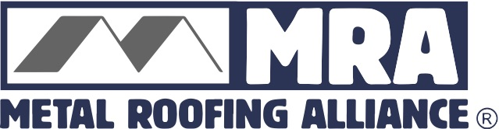
For high res images or additional information, contact: Darcie Meihoff, Metal Roofing Alliance (MRA), darcie@metalroofing.com or 971-998-3782

FOR IMMEDIATE RELEASE
January 25, 2021

AHEAD OF THE CURVE: GREEN KNIGHT® LANDS TOP HONORS IN MRA BEST RESIDENTIAL METAL ROOFING COMPETITION

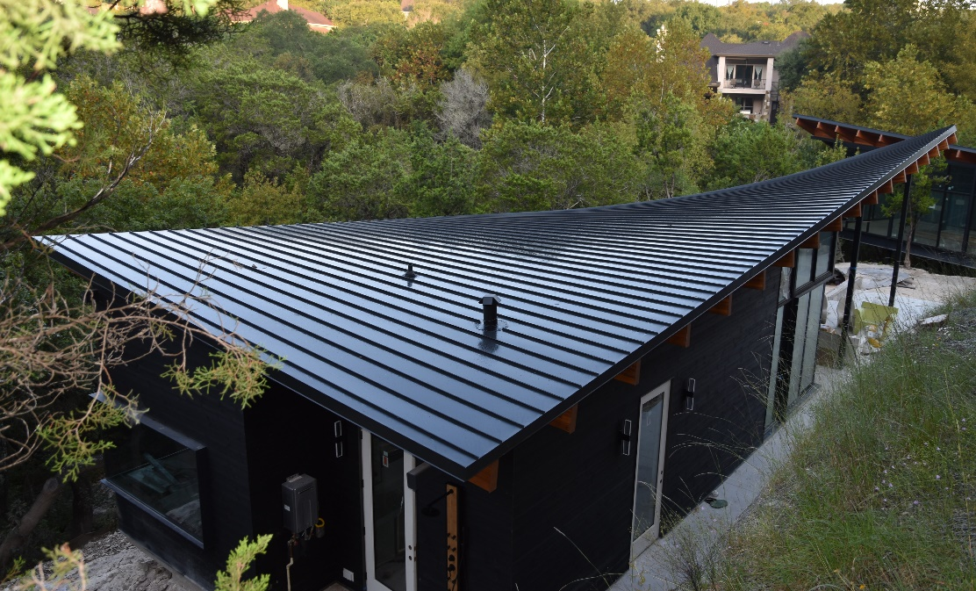
PORTLAND, Ore.—Green Knight Metal Roofing in Austin, Texas has landed top honors in the Metal Roofing Alliance’s (MRA) 2020 Best Residential Metal Roofing quarterly competition for a challenging, environmentally-friendly roofing project that features a custom, ultra-modern design.

The award-winning project is comprised of four separate residential buildings—each featuring a unique roof design—totaling 7,500 square feet. The curved roof of the newly-constructed home showcases the many benefits of metal roofing, including energy efficiency, sustainability and long-lasting reliability. The architect for the project was Bercy Chen Studio, also based in Austin.

“The gorgeous roofs featured in this project are truly an architectural highlight of the home,” said Renee Ramey, MRA Executive Director. “No other roofing material would have been able to achieve this incredible design, and best of all, it met all the goals the homeowners had for lessening their impact on the environment.”

In order to achieve optimal performance, Green Knight used a steel, double lock standing seam material with a thinner, 12-inch flat pan, manufactured by MRA member McElroy Metal. Finished with a high-performing black matte coating, the roof is designed to save energy, last for decades and stand up to Austin’s climate conditions, including hail and thunderstorms as well as intense summer heat.

Green Knight and McElroy Metal are the final winners of MRA’s Best Residential Metal Roofing Competition for 2020, however, MRA plans to continue the quarterly competition in 2021. This year, MRA will open the Best Residential Metal Roofing Competition to both trades (architects, builders, contractors, installers and manufacturers) and homeowners in the U.S. and Canada. One outstanding residential metal roofing project will be selected each quarter based on project appearance, performance and originality/use of materials. The entry deadline for the first quarter competition will close March 15, 2021. Interested participants may upload their project photo along with a 200-word or less description for why their metal roofing project is worthy of top honors online at metalroofing.com.

About Metal Roofing Alliance (MRA)
Representing the residential metal roofing industry in the United States and Canada, the Metal Roofing Alliance (MRA) was formed to help educate consumers about the many benefits of metal roofing. The main objective of MRA is to increase awareness of the beauty, durability and money-saving advantages of quality metal roofing among homeowners, as well as to provide support to the residential metal roofing industry. For more information, visit MRA at www.metalroofing.com.

