For high res images or additional information, contact: Darcie Meihoff, Metal Roofing Alliance (MRA), darcie@metalroofing.com or 971-998-3782

FOR IMMEDIATE RELEASE
December 8, 2020

SERIOUSLY ON TREND: MRA ANNOUNCES MOST POPULAR EXTERIOR HOME COLORS FOR 2021
Cravings for safety, security reflect homeowners’ top palette preferences this year

PORTLAND, Ore.—Color trend predictions reflect the current mood of consumers and it’s clear that for 2021, homeowners are in a more serious state of mind.
For the exterior of the home, colors that are subtle and subdued will be particularly popular in 2021, according to the Metal Roofing Alliance (MRA), a nonprofit industry trade group that represents leading metal roofing manufacturers and installers in the U.S. and Canada. With more color options available than any other roofing type, metal roofing color trends set the tone for the latest in homeowner style preferences and MRA members report that modern takes on natural earth tones will be in vogue among homeowners for the coming year.
“We’re definitely seeing a desire for serene, calming colors that reflect a sense of peace, security and grounding. After the turmoil of 2020, it’s no wonder homeowners are gravitating toward harmonious, warm and soothing earth tone colors that feel both solid and natural,” said Renee Ramey, MRA executive director.
For example, MRA member and leading paint manufacturer AkzoNobel announced “Brave Ground” as its 2021 color of the year, a warm natural neutral earth tone that is “all about bringing balance and stability” and can work together with other colors beautifully. Other members have selected palettes of beige that, far from boring, offer tranquility and reflection. MRA member and leading metal coil paint manufacturer Sherwin Williams recently unveiled its new Fluropon® Metal Trends Color Collection featuring eight curated color families created to mimic the classic aesthetic of natural and anodized metals: Gold and Brass, Bronze, Silver and Nickel, Blackened Steel, Copper, Steel, Zinc and Anodized. These high performance coatings achieve the desired look of natural metal roofing materials while delivering a long-lasting, consistent appearance and high performance, low maintenance benefits.
Stamped, stone-coated and patterned metal roofing designed to look like shake, shingles, slate and tile in natural tones of dark gray, bronze, clay and loam are booming in popularity and represent another trend stemming from a turbulent 2020. Unprecedented hurricane and wildfire seasons in the past year have homeowners clambering for more protective, longer lasting materials that reflect a traditional looks but are much more durable, sustainable and strong. MRA members such as Ideal Roofing in Canada report huge interest in metal roofing slate look-alike styles that can add tremendous curb appeal while withstanding severe storms in regions that experience extreme climate conditions.
“The importance of the natural world and the idea of home as a safe and secure sanctuary were some of the essential truths in 2020. In many ways, this year’s residential exterior color trends are a beautiful reflection of the priorities homeowners hold most dear,” said Ramey.
About Metal Roofing Alliance (MRA)
Representing the residential metal roofing industry in the United States and Canada, the Metal Roofing Alliance (MRA) was formed to help educate consumers about the many benefits of metal roofing. The main objective of MRA is to increase awareness of the beauty, durability and money-saving advantages of quality metal roofing among homeowners, as well as to provide support to the residential metal roofing industry. For more information, visit MRA at www.metalroofing.com.
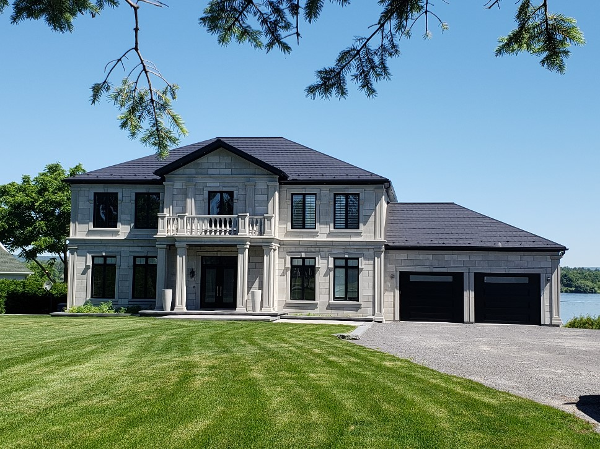
Suggested caption: Earth tones and subtle, calming colors are on trend for exteriors in 2021. (Image courtesy of MRA member Ideal Roofing)

