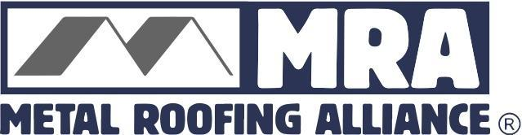
Contact: Darcie Meihoff, Metal Roofing Alliance (MRA), darcie@metalroofing.com or 971-998-3782

FOR IMMEDIATE RELEASE
November 6, 2020

BORAL STEEL® AND NICHTECH NAMED WINNERS OF MRA’S BEST RESIDENTIAL METAL ROOFING PROJECT COMPETITION FOR Q-3

PORTLAND, Ore.—The Metal Roofing Alliance (MRA) has selected Boral Steel® and NICHTECH as the winners of its Best Residential Metal Roofing Project competition for the third quarter of 2020.

The award-winning project features the installation of a new metal roof on a Tulsa, Okla. home that is just 10 years old. The original roof had been severely damaged by hail, which resulted in leaks and frustrating, unsuccessful attempts at roof repairs. Ultimately, the homeowners decided to replace the entire roof with a far superior metal roofing option that has not only significantly improved the performance and protection of their home, but added major style as well.

The material selected for the project was Boral Steel® PINE-CREST Shake stone-coated steel roofing, a lightweight solution benefiting from the strength of steel. The roof chosen delivers the stylish look of wood shake, but is manufactured to last and perform reliably for many decades to come. NICHTECH, the metal roofing installer for the project, was able to use Boral’s Elevated Batten System right over the old roof to help boost energy efficiency, save on tear-off costs and prevent waste. Even with the home’s complex roof design and elevations, the NICHTECH crew was able to complete the job in just four days and the end result highlights the home’s unique architecture beautifully.

“We take pride in all the projects we do, and this is a fantastic example of how using the right materials, installation methods and paying close attention to details can result in worry-free protection and performance for homeowners over the long run,” said Charles Nichols, owner of NICHTECH.

In addition to no more leaks, the homeowners also have noticed a major unexpected benefit from their new metal roof: The home better maintains comfortable indoor temperatures without the need to frequently adjust the thermostat. That’s because Boral’s system meets the minimum 0.85 R value for insulation above the roof deck, making it much more energy efficient and resulting in increased comfort and long-term money savings. The homeowners also can take comfort in the fact that their durable new roof can stand up extreme storms and hailstones.

“As an extremely lightweight and durable material, Boral Steel is ideally suited for roof retrofits of this kind,” says Marion Whorton, Boral Steel® territory sales manager covering OK, AR, KS & LA states. “And when you pair it with the Boral Elevated Batten System®, the homeowners’ long-term energy savings are meaningful.”

With the end of the third quarter’s competition, the search is now on for MRA’s final Best Residential Metal Roofing project for 2020 . Open to U.S. and Canada contractors, installers and manufacturers, MRA officials will select one outstanding metal roofing project based on project appearance, performance and originality/use of materials. Interested participants may upload their project photo along with a 200-word or less description for why their metal roofing project is worthy of top honors online at metalroofing.com. Next quarter’s winner will be announced in December, and only residential metal roofing projects in the U.S. and Canada will be considered.

For more information about how to enter MRA’s “Best Metal Roofing” competition for the trades, visit www.metalroofing.com
About Metal Roofing Alliance (MRA)
Representing metal roofing manufacturers in the United States and Canada, the Metal Roofing Alliance (MRA) was formed to help educate consumers about the many benefits of metal roofs. The main objective of MRA is to increase awareness of the beauty, durability and money-saving advantages of quality metal roofs among homeowners, as well as to provide support for metal roofing businesses and contractors. For more information, visit MRA.
# # # #
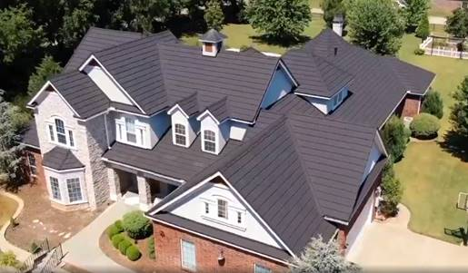
Suggested photo caption: MRA members Boral Steel® and NICHTECH won the Metal Roofing Alliance’s Best Metal Roofing Project competition this quarter for a high-performing, stylish stone coated metal roof installed on a Tulsa, Okla. home

