Strength, style & security: Making a smart investment for a cold climate and hot housing market
FOR OTTAWA HOMEOWNER, CHOOSING A METAL ROOF DELIVERS BEST LONG-TERM VALUE

The Project:
While property values in Ottawa, Canada have exploded in recent years, it wasn’t resell value that was foremost on the mind of one local homeowner when he decided to replace his roof. With plans to stay in his home forever, what ultimately drove his decision to install a quality metal roof was the peace of mind and headache-free protection it would provide, along with the style and beauty it would add to his 2,600 square-foot home.

The Challenge:
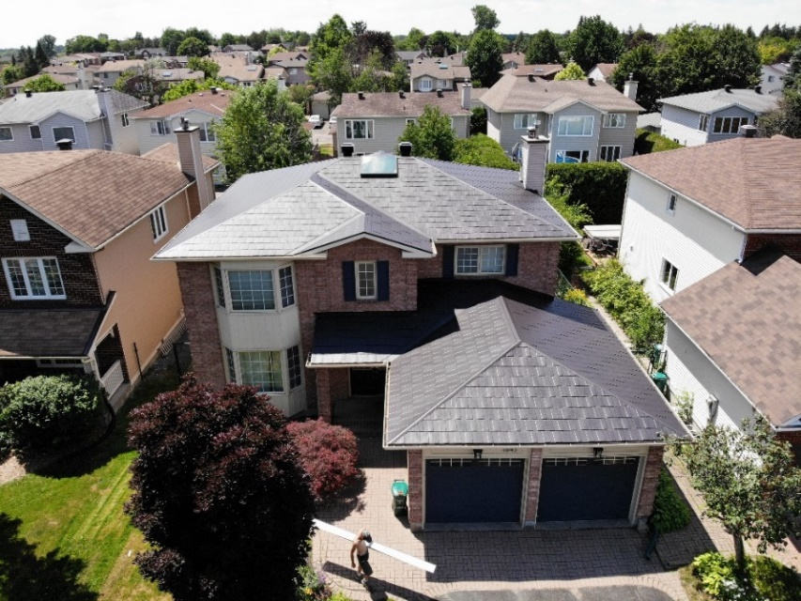
Ottawa, Canada is a hot housing market, but that doesn’t mean it’s not without its fair share of cold conditions. Ottawa homeowners need roofs that can stand up to heavy snow loads in the winter and major windstorms. The region also can experience tornados strong enough to rip entire roofs off. That’s driving demand for metal roofing as a strong, durable material that can hold up under such brutal conditions while adding style and beauty to maximize home values and curb appeal.

Spotlight on MRA member Ideal Roofing and installer Execon Roofing and Solar:
Having been inspired by the beautiful metal roofs in his neighborhood, and after researching the performance advantages, the homeowner chose Ideal Roofing’s Wakefield Bridge in Black Mica to re-roof his own home. As Ideal Roofing’s headquarters and hometown, the company has a 91-year history of expertise and providing exceptional metal roofing solutions that are well-suited to Ottawa’s unique climate challenges.

Even during the stress of the Covid pandemic and the resulting economic uncertainty, the homeowner forged ahead with the installation of his beautiful new roof just in time for the start of the winter season. Installer Execon Roofing and Solar took extra precautions to maintain social distancing and constant communications right from the start of the project planning process all the way through to completion. As a result, the homeowner now has a gorgeous new roof that not only adds tremendous curb appeal to his home, but also will offer reliable performance for whatever seasonal weather conditions lie ahead in Ottawa.

Thoughts from the Experts:
“We’re very proud to have been part of the Ottawa community for so long, helping ensure local homeowners have great quality metal roofing options that offer exceptional reliability and protection, and are also very well suited to our regional climate conditions,” said Philippe Laplante, Ideal Roofing.

For more information about Ideal Roofing, visit www.idealroofing.com

About Metal Roofing Alliance (MRA)
Representing metal roofing manufacturers in the United States and Canada, the Metal Roofing Alliance (MRA) was formed in 1998 to help educate consumers about the many benefits of metal roofs. The main objective of MRA is to increase awareness of the beauty, durability and money-saving advantages of quality metal roofs among homeowners, as well as to provide support for metal roofing businesses and contractors. For more information, visit MRA.

