Keys to a Successful Residential Metal Roofing Project

Posted by McElroy Metal ● July 09, 2020

A long-lasting metal roof is the product of three essential ingredients: quality substrates, superior coating, and skilled installation. All three of these elements must be present for homeowners to see a successful residential metal roofing project come to life. Cut corners on any one of the three elements and you run the risk that your roof will not deliver the ROI, quality, performance, and curb-appeal that you expect.
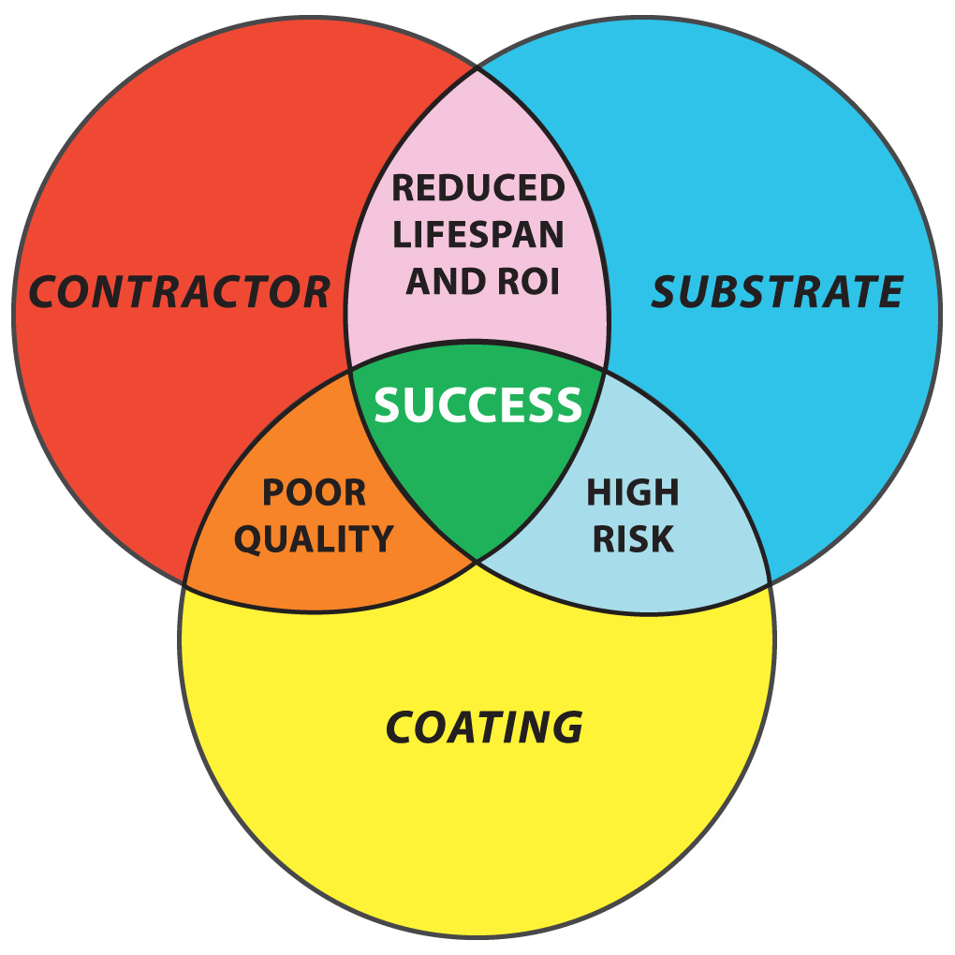
When shopping for metal roofing, homeowners must be vigilant to ensure that the metal substrate and the coating on the panels matches their long-term performance expectations. There are a variety of steel substrates and coatings available on the market and the wrong selection could result in a disappointed homeowners and reduced roof service life.

Choosing the best coating for your residential metal roof project
For long-term customer satisfaction and performance, metal roofs with a Galvalume® substrate and PVDF (Kynar 500®) coating have proven to retain the panel's original beauty for the long-term and offer the longest service life.

The coating/paint system is not only the part of your new metal roof that everyone will see, but it’s also a critical part of your overall metal roofing system. For the life of your metal roof (remember that can easily be 40 to 50 years), the coating will be exposed to Mother Nature’s elements: ultraviolet sunrays, acid rain, dirt, etc.
Over time, these environmental conditions can break down the coating, resulting in what is commonly referred to as panel fade and chalk. Fade and chalk are not pleasing to the eye, and the degree of fade and chalk is directly related to the coating system. The most popular coatings for metal panels are Polyester, Silicone-Modified Polyester (SMP) and Kynar 500® (PVDF). It’s helpful to think of these three paint systems in a Good, Better, Best ranking system.
Kynar 500 (PVDF) coatings are the best for a long service life, color retention, and chalk resistance. Selecting Kynar 500 (PVDF) means long-lasting “like new” appearance year-after-year versus Silicone Modified Polyester (SMP) coatings, which can begin to degrade and look aged due to fade and chalk.
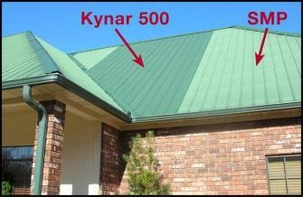

Both Kynar 500 (PVDF) and Silicone Modified Polyester (SMP) panels were installed on this project in Louisiana. On day one, the colors were an identical shade of dark green. The above photo, taken eight (8) years later, shows fading and chalking of the now lighter SMP panels. Note, no fade or chalking on the darker Kynar 500 (PVDF) panels.
Although a commercial application, the building below dramatically illustrates Kynar 500’s superior performance. This building was built in two phases, nine (9) years apart. Note, no color difference in the two halves of the roof. No Fade! No Chalk!
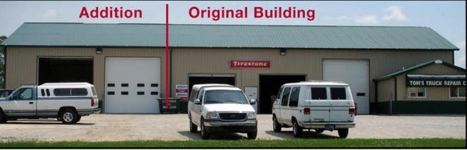

With examples like these, it’s obvious that Kynar 500® (PVDF) coatings are the “Best” option when long service life, color retention and chalk-resistance are important.
Yet, uninformed homeowners still often select a Silicone-Modified Polyester paint system. Why? It’s often because not every panel manufacturer or contractor offers Kynar 500® paint as one of their standard products. In those cases, installers may feel forced to sell the product they have available to them and oversell it as “just as good” as Kynar 500®.
Plainly put, there is no paint system that is presently equal to or better than Kynar 500®. Selecting Kynar 500® (PVDF) for your residential roof means a long-lasting “like new” appearance year-after-year versus Silicone-Modified Polyester (SMP) coatings, which can begin to degrade and look aged after only a few years. A metal roof is a big investment in your home. It’s important to understand these different types of paint systems, make your selection, and then only work with contractors who are willing to supply the product you select.

Choosing the best materials for your residential metal roof project
It’s important for homeowners to have an understanding of the components that make up metal roofing because not all metal panels are created equal. Just like most items you purchase on a daily basis, metal roofing has varying levels of quality and performance.
Maybe a more appropriate comparison is conventional shingles. If you have already replaced a shingle roof, you are well aware of varying levels of quality and performance. The same statement holds true for metal roofing: Quality and performance varies based on the quality of the metal substrate and coating (paint) system.
Let’s dig a little deeper into the steel substrate materials topic. Depending on your needs, the type of substrate you choose is one of the most important items to consider. The most popular steel substrates in the metal roofing industry are Galvanized and Galvalume®. Galvanized substrates are coated in zinc, while Galvalume® substrates are coated with an alloy of zinc plus aluminum.
Both Galvalume® and Galvanized are good substrates for metal roofing panels. With Galvanized substrates, the greater the amount of zinc, the greater the protection against panel corrosion. Two commonly used Galvanized substrates are designated as G100 and G60. These designations relate to the total amount of zinc contained on both sides of the panel surfaces. G100 contains 1.0 ounce of zinc for every one square foot of panel, while G60 substrates contain 0.6 ounces of zinc. The important fact to consider is that a G100 substrate contains 66% more protective zinc than a G60 substrate. This difference will have a direct correlation to panel longevity and long-term aesthetics of your project.
As a result, G60 substrates are simply not appropriate for residential roofing projects. Yet, they are widely available. For the uneducated consumer, it’s an easy mistake to make. For most applications, Galvalume® substrates offer the best long-term solution, and its superior performance has been proven in the field. Over five decades of testing and field performance have shown that Galvalume® delivers greater corrosion resistance compared to Galvanized panels. In fact, the performance of Galvalume® in the construction industry has been so superior that steel mills warranty it against rupture or perforation due to corrosion. Similar warranties simply do not exist for Galvanized substrates.
In one test, unpainted Galvalume® and Galvanized panels were placed in four different types of outdoor environments, including a normal marine and a rural setting. The harsher the surroundings, the better Galvalume® performed. After 23 years of side-by-side comparison in all areas, Galvalume® was two to four times more durable than Galvanized.
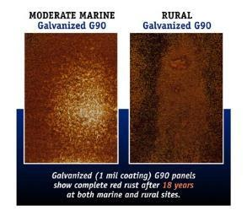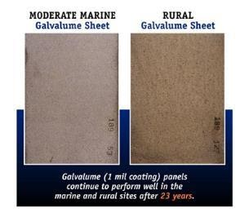

Color is important but avoid the mistake many homeowners make when shopping for metal roofing. Make sure that the substrate matches your long-term performance expectations. There are a lot of options available in the marketplace, and the wrong substrate selection could result in disappointment and a shorter life expectancy for your new metal roof.
In summary, if long-term performance and “like new” appearance are important criteria to you, metal roofs with a Galvalume® substrate and PVDF (Kynar 500®) are your best bet. Don’t be afraid to ask potential contractors what substrate and coating they recommend for your project. It could be a red flag if they don’t know or try to steer you toward lower-quality substrates and coatings.

Choosing the best contractor for your residential metal roof project
If you’re intrigued by all the benefits that metal roofing offers, the next step is to identify qualified contractors in your area who specialize in metal roofing. As you might guess, contractors that only “dabble” or occasionally install metal roofing often steer homeowners toward shingles because it’s their comfort zone. Do not let their comfort zone push you to accept a shorter-term solution for one of the biggest investments you have, your home.
These next steps are critical. Before picking up the phone or sending an email to request an estimate, take the time to check out the contractor a bit.
1. Ask around. Ask family and friends about their recent projects and who they would recommend.
2. Review contractor websites.
- Look for things like customer testimonials and types of products offered.
- If you can find any content on substrates and paint systems, give it a read.
- If they happen to list any vendors on their website, check out those websites, too.
- If they blog, take the time to read several blogs, and decide if they seem like a reputable company you’d like to work with.
- Look to see if there are names of owners/team members on the website.

3. Search the internet.
- While you’re online, do some general investigative work.
- In most cases, it’s as simple as doing an internet search for “reviews for XYZ Roofing in city, state” and hitting go.
- You may find plenty of positive things, which is great, but also be on the lookout for negative experiences reported to agencies like the Better Business Bureau.
- Read reviews and ratings.
After you’ve done your research and identified your top two or three contenders, it’s finally time to make the call. When you reach out, ask about their experience, product recommendations and process to get a metal roofing estimate.
While you’re certainly not limited, below are a few questions to help as you begin your conversations with contractors:
- How long have you been installing residential metal roofing?
- How many different metal roofing projects have you completed?
- What different types of systems have you used?
- Which system is your preferred one, and why?
- What substrate do you use?
- What paint system do you use for residential metal roof projects, and why?
- What training has your crew had for residential metal roofing?
- What warranty can I expect on both the product and the installation?
- If I have a warranty claim, does it include labor or just product replacement
- Could you give me a list of references where you’ve completed residential metal roofing?
Buying a new roof for your home is a huge investment and one that has long-term implications for your home's value, ongoing maintenance costs, risk of damage due to weather, and the enjoyment of your beautiful home. Reduce your risk and increase your chances of long-term success by choosing the right materials, with the right coatings, installed by the right contractor.

About McElroy Metal
Since 1963, McElroy Metal has served the construction industry with quality products and excellent customer service. The family-owned components manufacturer is headquartered in Bossier City, La., and has 13 manufacturing facilities across the United States. Quality, service and performance have been the cornerstone of McElroy Metal’s business philosophy and have contributed to the success of the company through the years. As a preferred service provider, these values will continue to be at the forefront of McElroy Metal’s model along with a strong focus on the customer.

