A Solar-Friendly Metal Roof Tops this Net Zero Post Frame Home

Posted by McElroy Metal ● May 26, 2020

On a mission to construct a long-lasting, low-maintenance Net Zero post-frame home, Corbin Borkholder was careful about the products he selected, including a specific McElroy Metal roofing profile to host the solar laminate panels.
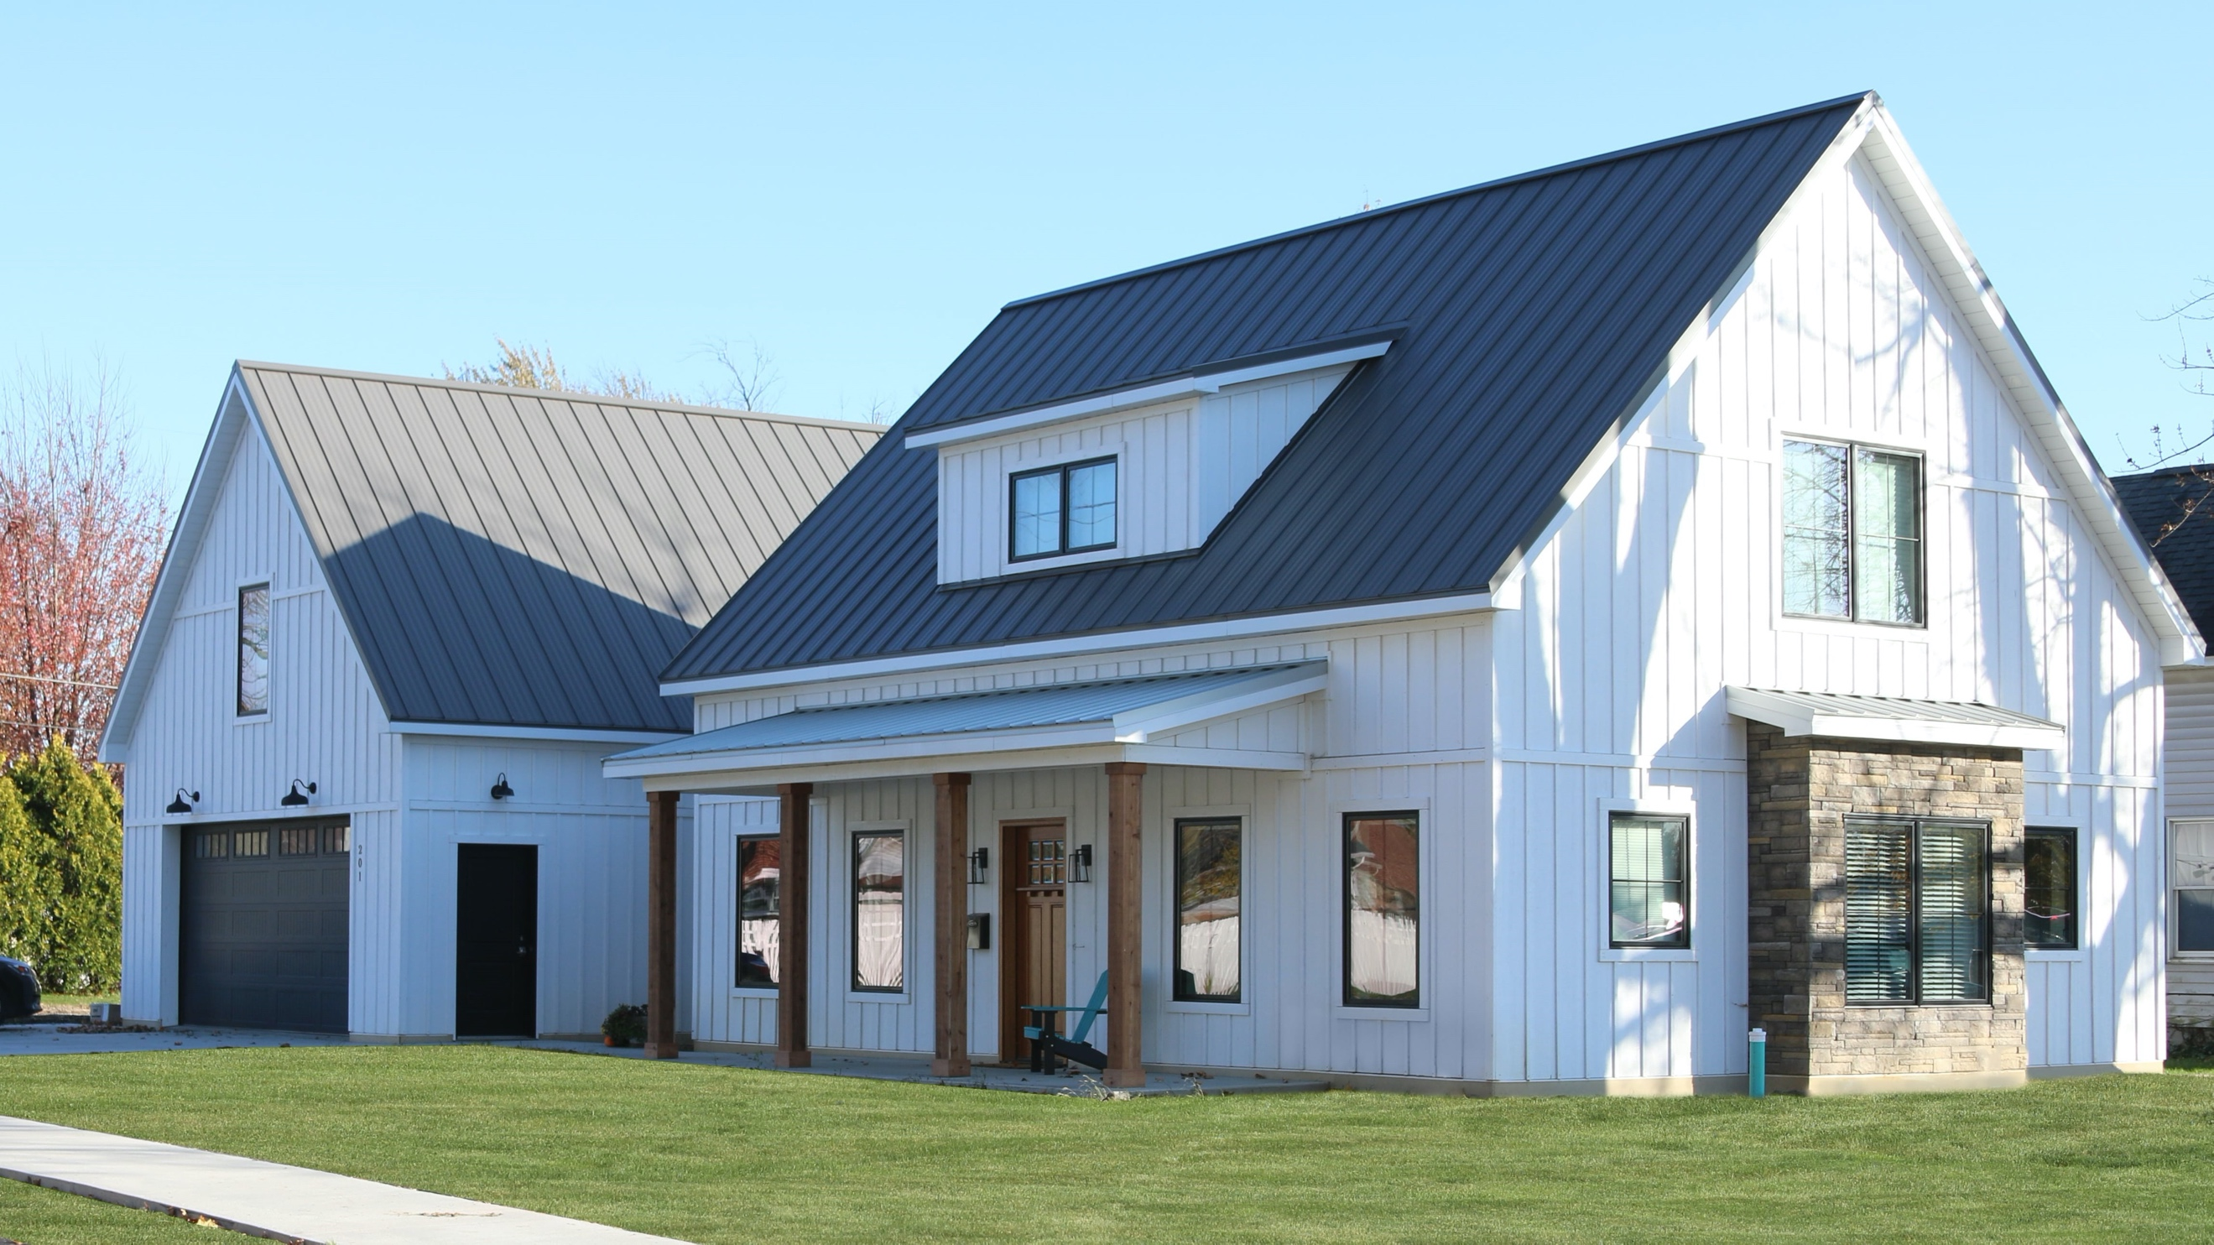
Borkholder is a sales representative for Borkholder Buildings, a custom builder based in Nappanee, Ind., where the company’s corporate offices, engineering center, lumberyard and truss manufacturing plant are located. This is Borkholder’s home, completed in September 2019. It was the Residential winner of the 2019 National Frame Building Association’s annual Building of the Year awards.
“I wanted an energy efficient home with minimal maintenance,” Borkholder says. “It’s a post-frame home on a slab. I was the general contractor with multiple subs. This was a great way for me to learn more about the low-energy homes we offer. It’s a product I now live in and I believe in and it’s helped me with my presentation to customers.”
According to the NFBA, post-frame construction is an “engineered wood-frame building system that meets UBC and IBC standards. Post-frame buildings feature large solid sawn posts or laminated columns instead of wood studs, steel framing or concrete masonry. These posts or columns transfer loads to the ground or are surface-mounted to a concrete pier or masonry foundation and may use plastic barrier systems for enhanced protection of wood and concrete posts or piers.”
Borkholder says he also keeps the place as clean as he can because he has shown his home to dozens of customers in the first six months since its completion. “I want them to see what we can do,” he says.
Borkholder chose McElroy Metal coil to produce 1-3/4-inch snap-lock standing seam roofing panels, which are recognized as ideal laminate panel hosts by MiaSole of Santa Clara, Calif. The roofing panels were formed onsite by Premier Roofing and Construction of Nappanee. The striated 16-inch wide panels that cover the majority of the home are coated with Sherwin-Williams Fluropon PVDF in charcoal. The panels on the porch are Fluropon PVDF in Silver Metallic.
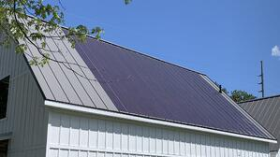
MiaSole’s solar panels are offered in different lengths, but to achieve the desired 6 kW system for a Net Zero rating for a home this size, Borkholder had to go with the 19-foot laminate solar panels on the south side of the home. To install 19-foot laminate panels on metal roofing, the roof had to be constructed to a slope of 12:12. With that, the home required 3,130 square feet of roofing. Borkholder Buildings manufactured the custom trusses for the home. The laminates were attached to the roofing panels on the ground – it’s safer and easier to install them straighter and then roll them down and make sure they are properly adhered. The panels are also cleaner before being installed, so the solar laminate panels adhere better than they would to dust-covered metal.
Borkholder says with the 30 percent tax credit, the return on the solar investment is expected to be 8-10 years.
In addition to the reflective roofing coating and the solar panels, other components that helped the home achieve Net Zero status were LP Smart Siding, various insulations and in-floor electric heating from Danfoss Power Solutions.

About McElroy Metal
Since 1963, McElroy Metal has served the construction industry with quality products and excellent customer service. The family-owned components manufacturer is headquartered in Bossier City, La., and has 13 manufacturing facilities across the United States. Quality, service and performance have been the cornerstone of McElroy Metal’s business philosophy and have contributed to the success of the company through the years. As a preferred service provider, these values will continue to be at the forefront of McElroy Metal’s model along with a strong focus on the customer.

