S-5! Recognized for Its Contribution to Sustainability of Innovative California Community
19 Feb 2020

S-5! Metal Roof Innovations (S-5!), the leading authority on metal roof attachment solutions, announced it has been awarded the Metal Construction Association (MCA) Chairman’s Award for metal construction projects of 2019 in the residential category.

Each year the MCA recognizes outstanding metal construction projects in North America. The chairman's award goes to exceptional buildings involving MCA member companies. The criteria include overall appearance, significance of metal in the project, innovative use of metal and the role of metal in achieving project objectives.

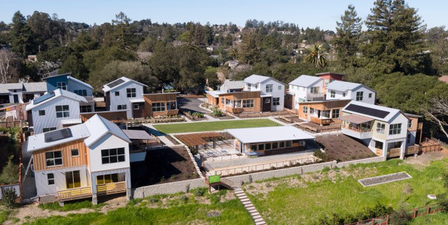

S-5! was recognized at the MCA annual Winter Meeting Awards Dinner in Palm Springs, California in January, for its metal roof attachment solutions utilized in the Keller Court Commons project in Petaluma, California–a tight-knit “pocket neighborhood” of eight houses with a central grassy courtyard and a small common building.

Keller Court Commons Developer, Jim Soules worked together with Principal, Chris Lynch of MAD Architecture to design a neighborhood that draws on the historic agricultural influences of its surrounding area―delivering a low-maintenance, sustainable community demonstrated in the standing seam metal roofing, corrugated metal wall panels, solar arrays and brilliant color palette.

Since sustainability was a major consideration and metal building components are a significant contributor to the durability, maintenance requirements and sustainability of the community, they chose metal roofing. MAD Architecture selected S-5! attachment solutions to attach the solar panels to the standing seams, including its S-5-N clamps, which feature an angled setscrew and an innovative clamp insert to ensure a superior fit whether placed on older profiles or new and wider nail strip profiles.

"We chose S-5!'s attachment solutions for the Keller Court Commons project because we liked the idea of eliminating multiple penetrations through the roof to install the PV racks, and we knew S-5!'s zero-penetration clamps, designed to last the life of the roof, would not violate the roof integrity," said Lynch. "We are very happy with the results and expect to use S-5! attachment technology again on future projects."

The Keller Court Commons project team includes land developer: Soules Co.; architect: MAD Architecture; general contractor/metal panel installer: Jacobs Classic Construction; metal roof installer: Crandall Roofing; solar panel installer: Suntegrity Solar; solar panels: Enphase Energy Inc.; accessory supplier, roof clamps: S-5! Metal Roof Innovations; and metal roof/wall panel manufacturer: Metal Sales Manufacturing.

Award recipients were chosen from projects submitted by MCA members and presented in the following six categories: Overall Excellence and Commercial/Industrial, Education: Colleges & Universities, Institutional, Municipal, Roofing and Residential. This year's panel of judges included architects: James Theimer, principal architect, Trilogy Architecture; Mark Roddy, lecturer in the department of design, California State University; and Erik Mehlman, partner and design lead at BuildSense | Architecture + Construction.

Accepting on behalf of the S-5! team was CEO and Founder Rob Haddock. Haddock, a well-known metal roof consultant, author, speaker and inventor of the non-invasive clamps for fastening accessories to standing seam metal roofs has worked in various aspects of metal roofing for almost five decades. His unwavering confidence in metal roof superiority-built S-5!’s strong foundation. His attachment solutions make metal the most user-friendly roof type on the market, maintaining S-5!’s dominance as the industry leader in that field.

“It is an honor to be recognized for our attachment technology utilized on every metal roof in this innovative community and a privilege to be part of a project that values the long-term sustainability of metal building components in construction,” said Haddock.

