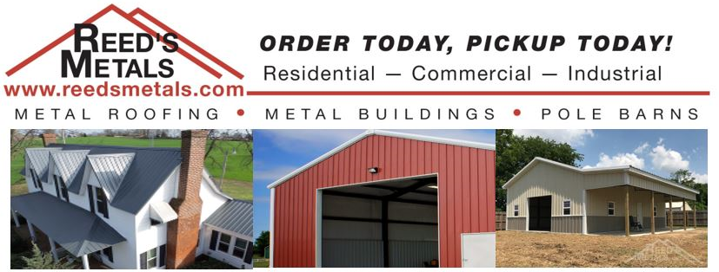

Reed's Metals is OPEN for BUSINESS and ready to help you!
Reed's Metals is open for business and falls within the definition of essential business [or supplier of an essential business] as defined in the Executive Order. Essential businesses are allowed to stay open as they are vital to the economy. As an essential business we will remain open during this time as we strongly support multiple essential businesses. We take the health and safety of our employees and customers very seriously and are taking measures to lessen the risk of exposure as much as possible. At Reed's Metals, you can buy direct and save! If we can be of service to you for your residential, commercial or industrial metal roofing or panel needs, please feel free to give us a call at 1-800-581-4645, visit our website at www.ReedsMetals.com or stop by one of our 8 locations.

