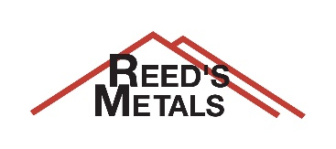
Know Your Roof

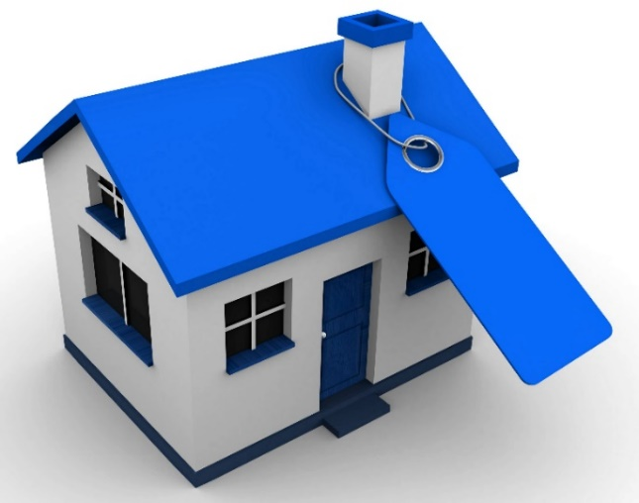
Some manufacturers even with well-known brands are selling a sub-par AZ35, so be careful. Make sure you are getting the best metal for your project.

Metal for roofing is comprised of layers.
Ask Before
you Buy
- STEEL for strength
- SUBSTRATE for rust prevention
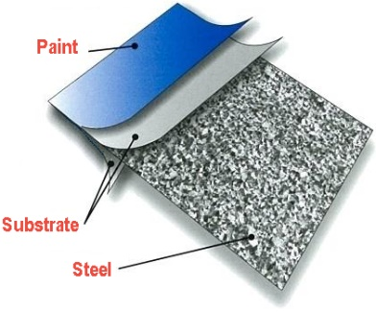
- PAINT for color and protection
What gauge to choose.
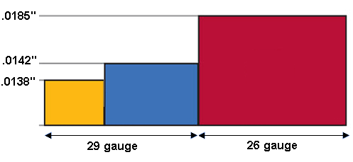
STEEL – Gauge indicates the thickness of the panel. Each gauge number represents a range of thickness, meaning a 29- gauge panel could be as thin as .0115” or as thick as .0155”. Industry-standard 29-gauge metal for roofing is .0142”. Know what you are buying. Ask for the manufacturer’s specifications on metal thickness.
A lower gauge number indicates heavier steel. Heavier steel resists dents and wind-uplift. It also can span larger framing for pole barns and buildings. Lighter, more economical 29-gauge steel may be preferred for residential roofing with solid decking. Be sure it is the thicker 29-gauge that would be less prone to denting.
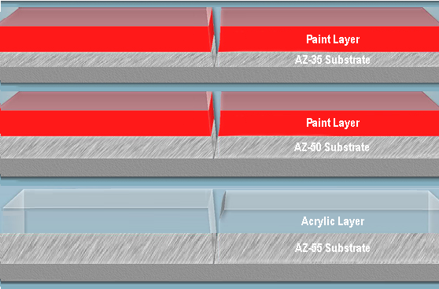
Thicker is better.
SUBSTRATE – To protect the steel core from rusting, roofing metal has an aluminum-zinc alloy coating Thickness of the coating is measured in weight over 100 square feet (AZ-55 = 55 ounces of aluminum-zinc alloy per 100 square feet). Quality metal roofing has AZ-50 and AZ-55 substrates to provide a thicker coat of anti-rust protection.

PAINT – A .9 to 1 mil acrylic or paint layer (comprised of pigment, resin, and solvent) protects lower layers from the elements, while the paint gives fade-resistant color and gloss. Economy or non-warranted panel may have less. Be sure you are getting a superior paint layer.

