Clay Tile vs. Metal Roofing: What You Need to Know
Trevor Underwood • Feb 25, 2020

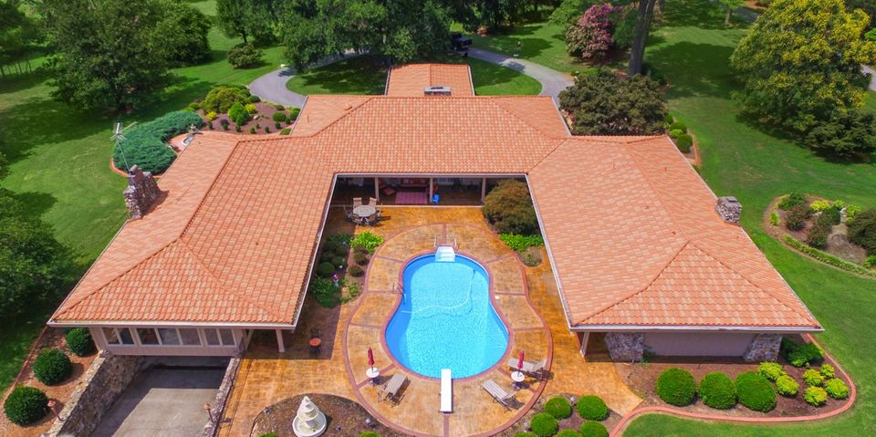

Clay tile was once the most popular roofing material of its time, far superior to wood for fire resistance and weather durability, with color, beauty, and form that flat asphalt shingles and common woodcut shakes simply couldn’t match. But there is a high price to be paid with clay tile roofing as it is one of the most fragile and high-maintenance roofing materials on the market.
Today, discerning homeowners have moved away from high-maintenance clay tile to metal roofing products that replicate the ageless beauty of clay tile with the unsurpassed strength and durability of steel.

10 Reasons to Upgrade to a DECRA Metal Roof
Clay Tile | DECRA Metal Roofing
Ornate textures and vivid colors that enhance the traditional aesthetics of classic roof designs | Ornate textures and vivid colors that enhance the traditional aesthetics of classic roof designs
Requires continuous ongoing maintenance to fix cracks | Requires minimal maintenance over the lifetime of the home
Fractures easily due to storm debris and hail | Has the highest UL 2218 Class 4 impact rating
Absorbs as much as 15% of its weight in moisture, adding weight stress to the roof | impervious to the absorption of moisture, sleet, snow, and rain
Extremely limited and non-transferable warranty | The industry’s most comprehensive Lifetime Limited Warranty which is transferable for 20 years after the installation
Wind uplift and impact resistance are so minimal that they aren’t rated or covered by any warranty | Warrantied for winds up to 120 mph and lab tested at twice that velocity to provide a 100% safety margin (soften the 100% claim)
Walking on clay roofs for maintenance can easily cause damage | Fully walkable with the unmatched strength of high-grade multi-layered steel
One of the heaviest roofing materials with an average roof weight of 18,000 to 45,000 pounds | One of the lightest roofing materials with an average roof weight of just 3,700 to 4,500 pounds
Complete tear-offs of the existing roof are usually required adding time and expense to the installation | The lightweight characteristics of DECRA roofs often eliminate the need for a complete tear-off (if one DECRA panel is damaged, you can replace that individual panel)
Inevitable loosening around the tile fasteners can cause noise when loose tiles rattle against each other in the wind | Corrosion-resistant fasteners and a proprietary interlocking system to keep roof panels firmly in place

DECRA Metal Roofing products are designed to bridge the gap between durability and beauty, without the compromises in strength and longevity that come with clay tile.
Whether you’re looking for the robust form of barrel-style Spanish tile or the distinctive S-shape of Classic Mediterranean scalloped tile, DECRA has the style and color to effortlessly match any architectural theme.

DECRA Villa Tile: Spanish Style Barrel Tile
Elegant Old-World designs frequently rely on prominent, complex, round roof elements such as cupolas and towers. The semi-cylindrical barrel shape of DECRA Villa Tile perfectly mimics the traditional Spanish and Roman barrel styles to accommodate the elegant curves of Italian Villa, Spanish Colonial, and Mission Revival traditions.
DECRA Tile: Mediterranean Style Scalloped Tile
Scallop style tiles have the wavy S-shape which provides a distinctive rippled or scaled texture to complement classic roof elements so prevalent in Mediterranean Villa styles. DECRA Tile replicates the distinctive style and texture of scalloped clay tiles.

About DECRA Metal Roofing

DECRA is the original stone-coated steel roofing manufacturer since 1957. DECRA products are manufactured right here in the U.S. at our state-of-the-art facility in Corona, California. While we have many imitators, none has yet matched the lifetime quality and ageless beauty of DECRA stone-coated steel roofing profiles, all backed by the industry’s most comprehensive Lifetime Limited Warranty.

