What is a Class Four Roof?

Posted by McElroy Metal ● September 17, 2019

Class four is an impact standard used to rate roofing materials like shingles and metal materials.
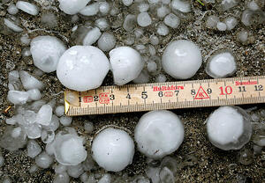
Underwriters Laboratories (UL) is a not-for-profit independent testing organization that delivers the verified information to help consumers make accurate decisions about products like impact-resistant roofing materials. UL developed a test to rate the strength of roofing materials called the UL 2218 Impact Rating, which is the test that determines if a roofing material is Class 1,2,3, or 4.
The hail standard UL 2218 essentially encompasses four different sized metal balls being dropped from different heights (to simulate hail, more or less). The test is considered failed if there is tearing, fracturing, etc.
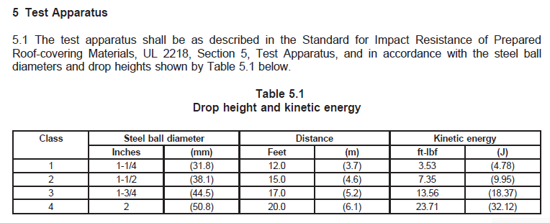

Benefits of Impact Resistant Roofs
- lower lifetime roof costs
- lower insurance premiums
- less repair and replacement

Are all shingles and metal roofs class 4 roofs?
Most shingles are not impact rated, and those that are Class 4 run 10-20% more expensive that those that are not Class 4 rated. Many metal roofs are impact resistant and will be rated Class four. McElroy Metal has over two dozen profiles in steel that are Class 4 rated in thicknesses all the way down to 29 gauge. Class 4 ratings in alternative metals such as aluminum and copper are also available (though much less frequent).

How do I know if I have an impact-resistant roof?
Shingles are rated Class 1 through 4, with Class 4 shingles having the highest resistance. The impact rating is usually marked on the underside of the shingle or on the packaging. You will not be able to tell the impact rating by looking at a shingle.

What does it take to get a Class 4 rating?
A 2” in diameter steel ball is dropped from 20’ onto the roof. In order to be accepted, it can “show no evidence of tearing, fracturing, cracking, splitting, rupture, crazing or other evidence of opening.”

Why is impact resistance important?
Impact resistance is important because it’s a measure of resistance to hail and debris. Generally speaking, you can’t label something as “hail proof” but those products that have been classified as Class 4 have met the strongest level of resistance that UL has deemed appropriate. So purchasing products that are Class 4 rated means you will have a smaller likelihood of damage after a hail event or a storm where debris has made contact with your roof. Furthermore, replacing a roof is not the only expense when roofing fails – if the hail/debris causes a leak, additional damage is likely to occur inside the building. With Class 4 rated metal systems, your roof is far more likely to remain watertight even after storm damage.

About McElroy Metal
Since 1963, McElroy Metal has served the construction industry with quality products and excellent customer service. The family-owned components manufacturer is headquartered in Bossier City, La., and has 13 manufacturing facilities across the United States. Quality, service and performance have been the cornerstone of McElroy Metal’s business philosophy and have contributed to the success of the company through the years. As a preferred service provider, these values will continue to be at the forefront of McElroy Metal’s model along with a strong focus on the customer.

