The Protection of a Durable Roof

Posted by McElroy Metal ● July 23, 2019

With coastline hurricanes and West coast wildfires making big headlines across the US, many homeowners are turning to metal roofing as a sustainable, long-term roofing solution because it offers excellent durability in the face of extreme weather.

Durability in the Face of High Winds, Hail, and Fire
No building material is entirely damage-proof. That being said, a metal roof does offer significant strength and resistance to damage from environmental factors like high wind, hail, and fire. For homeowners in hurricane-prone areas, fire-prone areas, and areas that see significant hail, metal roofing is a sustainable product that performs much better than other roofing materials.
The sustainability and durable of metal roofing are explored in depth in an eBook from the Metal Roofing Alliance (MRA) called Sustainable Masterpieces. In this eBook Renee Ramey, executive director of the Metal Roofing Alliance points out that, “The performance of metal roofing in these weather extremes has become much more visible…Metal roofing’s ability to withstand these disasters and protect a home’s structure inside and out has definitely caused interest in metal roofing to increase among homeowners.”
And the increase in interest in metal roofing isn’t surprising. Roofing is a significant expense for homeowners and those in storm-prone areas know that even when a roof doesn’t need to be replaced entirely, damage repairs can add up. In fact, “recent reports show that hailstorm costs are increasing in the United States, averaging $8 billion to $10 billion in damage annually and accounting for 70 percent of insured loss from severe storms.”
However, metal roofing does tend to cost more upfront than other roofing materials.
“Metal roofing may cost more initially, at the time of install, but the long-term costs are typically less over the life of the roof,” Ramey explains. “Why? Because a quality metal roof will last three to four times longer than an asphalt roof. While you may pay more at first, you are not paying to replace your roof every 10 to 15 years, which is typically how long an asphalt roof will last.”
It is essential to weight the durability and longevity of your roofing material against upfront costs so that you can get the best roof possible for your home.

Metal Roofing: A Sustainable Environmentally Conscious Option
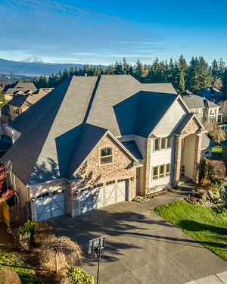
Metal roofing doesn’t just offer homeowners exceptional durability and longevity; metal roofing is also a sustainable building material. Not only is metal roofing often manufactured from recycled metal it is completely recyclable at the end of its lifespan. So, not only does metal roofing need to be replaced less often than shingles, it also doesn’t end up in a landfill when its time to replace it.
Renee Ramey states that “people typically consider ‘sustainable products to be recycled, upcycled, or resource-efficient. However, just as important as these attributes are how long a product lasts. The embodied energy of creating products—even if they are made from recycled materials—is multiplied over and over if that product has a short life span and must be replaced often.”
The sustainability of metal roofing and its longevity are two reasons why metal roofs can often be found in green building programs like LEED or the National Green Building Standard.
And while it might not be surprising to savvy homeowners that metal roofing is considered a green building material, metal roofing also offers another environmentally-friendly advantage that is often overlooked. “In addition, the quality coatings on a metal roof provide an environmental advantage because they resist moss and fungus growth, and reduce the need for strong chemical treatments that can be harmful to the environment” according to Ms.Ramey.

Some Advice for Selecting a Metal Roof
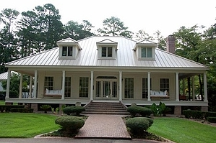
Not all metal roofs are the same. It is essential that homeowners do their research before purchasing a new metal roof. MRA recommends a number of steps for evaluating a roof, the supplier, and the manufacturer, including finding out:
- Where the roofing material was manufactured
- The type of metal and protective coatings that are used
- Product and installation warranties
- The testing and regulation standards the manufacturer adhere to
- Performance ratings for severe weather and fire
- Customer support available
- How long has the manufacturer been in business and how are they reviewed
- Is the manufacturer a member of MRA

Learn More
Want to learn more about the durability and sustainability of metal roofing? The Sustainable Masterpieces eBook is an excellent resource with examples of metal roofing performing in a vast array of climates. You can download a copy of the Sustainable Masterpieces eBook here.

Learn everything you to know about Residential Metal Roofing. Check our out metal roofing resources for inspiration and answers to your questions.

