Metal roofing offers homeowners a lot of advantages (long service-life, energy-efficiency, aesthetics), but over the years there have been a few metal roofing myths that have persisted. So, let’s take a look at some of the most common metal roofing myths and debunk them once and for all.

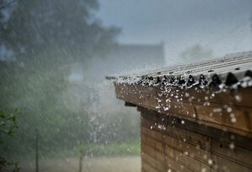
Myth: Metal Roofing is Noisy
This might be most common metal roofing myth, and we attribute the myth to pole buildings and garages. If you’ve ever been in a garage or a barn with a metal roof during a rainstorm, you know that it can get noisy. What you might not realize is that those types of building most often don’t have any of the decking or insulation that a home has.
When a metal roof is installed on a residential property, it is installed over a roof deck, insulation, and underlayment. These additional layers dampen the sound of even the most intense rainstorm. A properly installed residential metal roof won’t be any louder than any other type of roofing material.
Check out this video to hear what a rainstorm sounds like in a home with a metal roof.

Myth: Metal Roofing Will Increase Energy Costs
The truth is that metal roofing will actually lower your energy costs!
Metal roofing reflects the sun’s heat and energy, which can actually save you as much as 20% in your cooling energy costs.

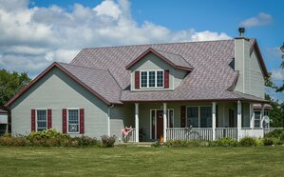
Myth: Metal Roofs are Ugly/Won’t Look Good on My Home
In all fairness, aesthetics is very personal. What one homeowner loves another might not.
That being said, all metal roofing does not look the same. There are a lot of styles, finishes, and color options on the market today, so if one type of metal roofing isn’t your cup of tea visually, you have options.
Like the look of shingles, slate, or tile roofs? There’s a metal roofing style for that! And don’t forget all of the color and finish options too!

Myth: Metal Roofing Will Attract Lighting
Although metal can conduct electricity, lighting isn’t necessarily attracted to metal roofing. Lighting will strike the closest target. Homes with metal roofs are no more prone to lightning strikes than homes with any other roofing material.
In fact, metal roofing is non-combustible, so if your roof is struck by lighting, it won’t catch on fire like other building material.

Myth: Metal Roofing Gets Easily Damaged by Hail or Wind
The truth is that any roofing material can sustain damage from environmental factors like hail, debris in high winds, or forest fires. The good news is that metal roofing offers some resistance to this type of damage.
Metal roofing is more resistant to hail than shingles, naturally resistant to fire, and (when properly installed) is resistant to high winds!
Want to see some proof? Check out these stories about metal roofing:
An ABC Nightly News story about a metal roof surviving a forest fire
A New York Times article about a home surviving Hurricane Florence
After the devastation Hurricane Irma caused in the Florida Keys, there are calls to make metal roofing mandatory in Monroe County.

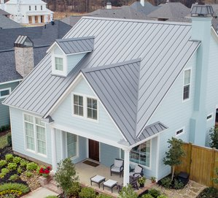
Myth: Metal Roofing is Expensive

This myth is actually true if all you are doing is comparing upfront installation costs for metal roofing and shingles. If all you are looking at is the upfront price, metal roofing is often more expensive than shingles.
However, metal roofing can last 2 to 3 times as long as shingles. Metal roofing can also lower utility expenses and requires less maintenance than shingles.
With all that taken into consideration, metal roofing very often actually costs “less” money over time.
You can learn more about the value of a metal roof versus a shingles roof here.

Myth: Metal Roofing is All the Same
Metal roofing is just like any other product in that there are varying degrees of quality, longevity, and performance. It is vital to understand substrate, gauge, paint system, and panel options when selecting a metal roofing system.
You can learn more about residential roofing substrates, coatings, warranties, and panel options in our new eBook, the Residential Metal Roofing Guide. Click the link below to download your copy!

