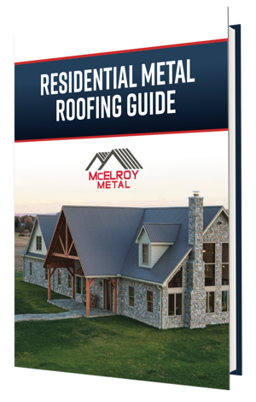
Replacing your roof is a big decision with a lot of options. Balancing price, energy efficiency, warranties, and longevity can be time-consuming and frustrating, but we’ve created a roofing guide to help you navigate these options and choose the perfect roof for your home.
Residential metal roofing offers homeowner’s significant longevity, energy efficiency, and durability benefits, but selecting the best options for your roof can be difficult. Nuances in warranties, substrates, and paint systems can have significant impacts on the performance of a metal roof, but many homeowners aren’t familiar with these topics.
We created a guide specifically to help homeowners navigate the metal roofing purchasing process from finding a contractor to selecting a paint system. The Residential Metal Roofing Guide is an in-depth exploration of everything you need to know to select the right roof for your home.
The Residential Metal Roofing Guide will help you:
- Choose between a metal roofing system and asphalt shingles
- Find the perfect panel style for your family’s home
- Select a paint coating that will keep your home looking beautiful for the next 40 to 50 years
- Decide between G60, G100, and Galvalume substrates
- Evaluate contractors before picking up the phone or sending a single email
- Determine what to look for in a warranty
Follow the link below to download your copy of the Residential Metal Roofing Guide!

