ProteaBracket™
The Right Way™ to attach solar PV to trapezoidal roof profiles!

ProteaBracket™ is now made in aluminum. Still the most versatile trapezoidal metal roof attachment solution on the market, the S-5! ProteaBracket just got better! The bracket features an adjustable attachment base and module attachment options to accommodate different roof profile dimensions and mounting options.

Our pre-applied EPDM gasket with peel and stick adhesive makes installation a snap, ensuring accurate and secure placement the first time. With no messy sealants, faster installation, and a weather-proof fit, ProteaBracket offers you the most versatile solar attachment solution available.

ProteaBracket* can be used for rail mounting or “direct-attach” with S-5! PVKIT™
*When ProteaBracket is used in conjunction with the S-5-PVKIT™, an additional nut is required during installation.

Features and Benefits
- 34% lighter – saves on shipping
- Stronger L-Foot™
- Load-tested for engineered application
- Corrosion-resistant materials
- Adjustable – Fits rib profiles up to 3″
- Peel-and-Stick prevents accidental shifting during installation
- Fully pre-assembled
- 25-year warranty

CAD Drawings
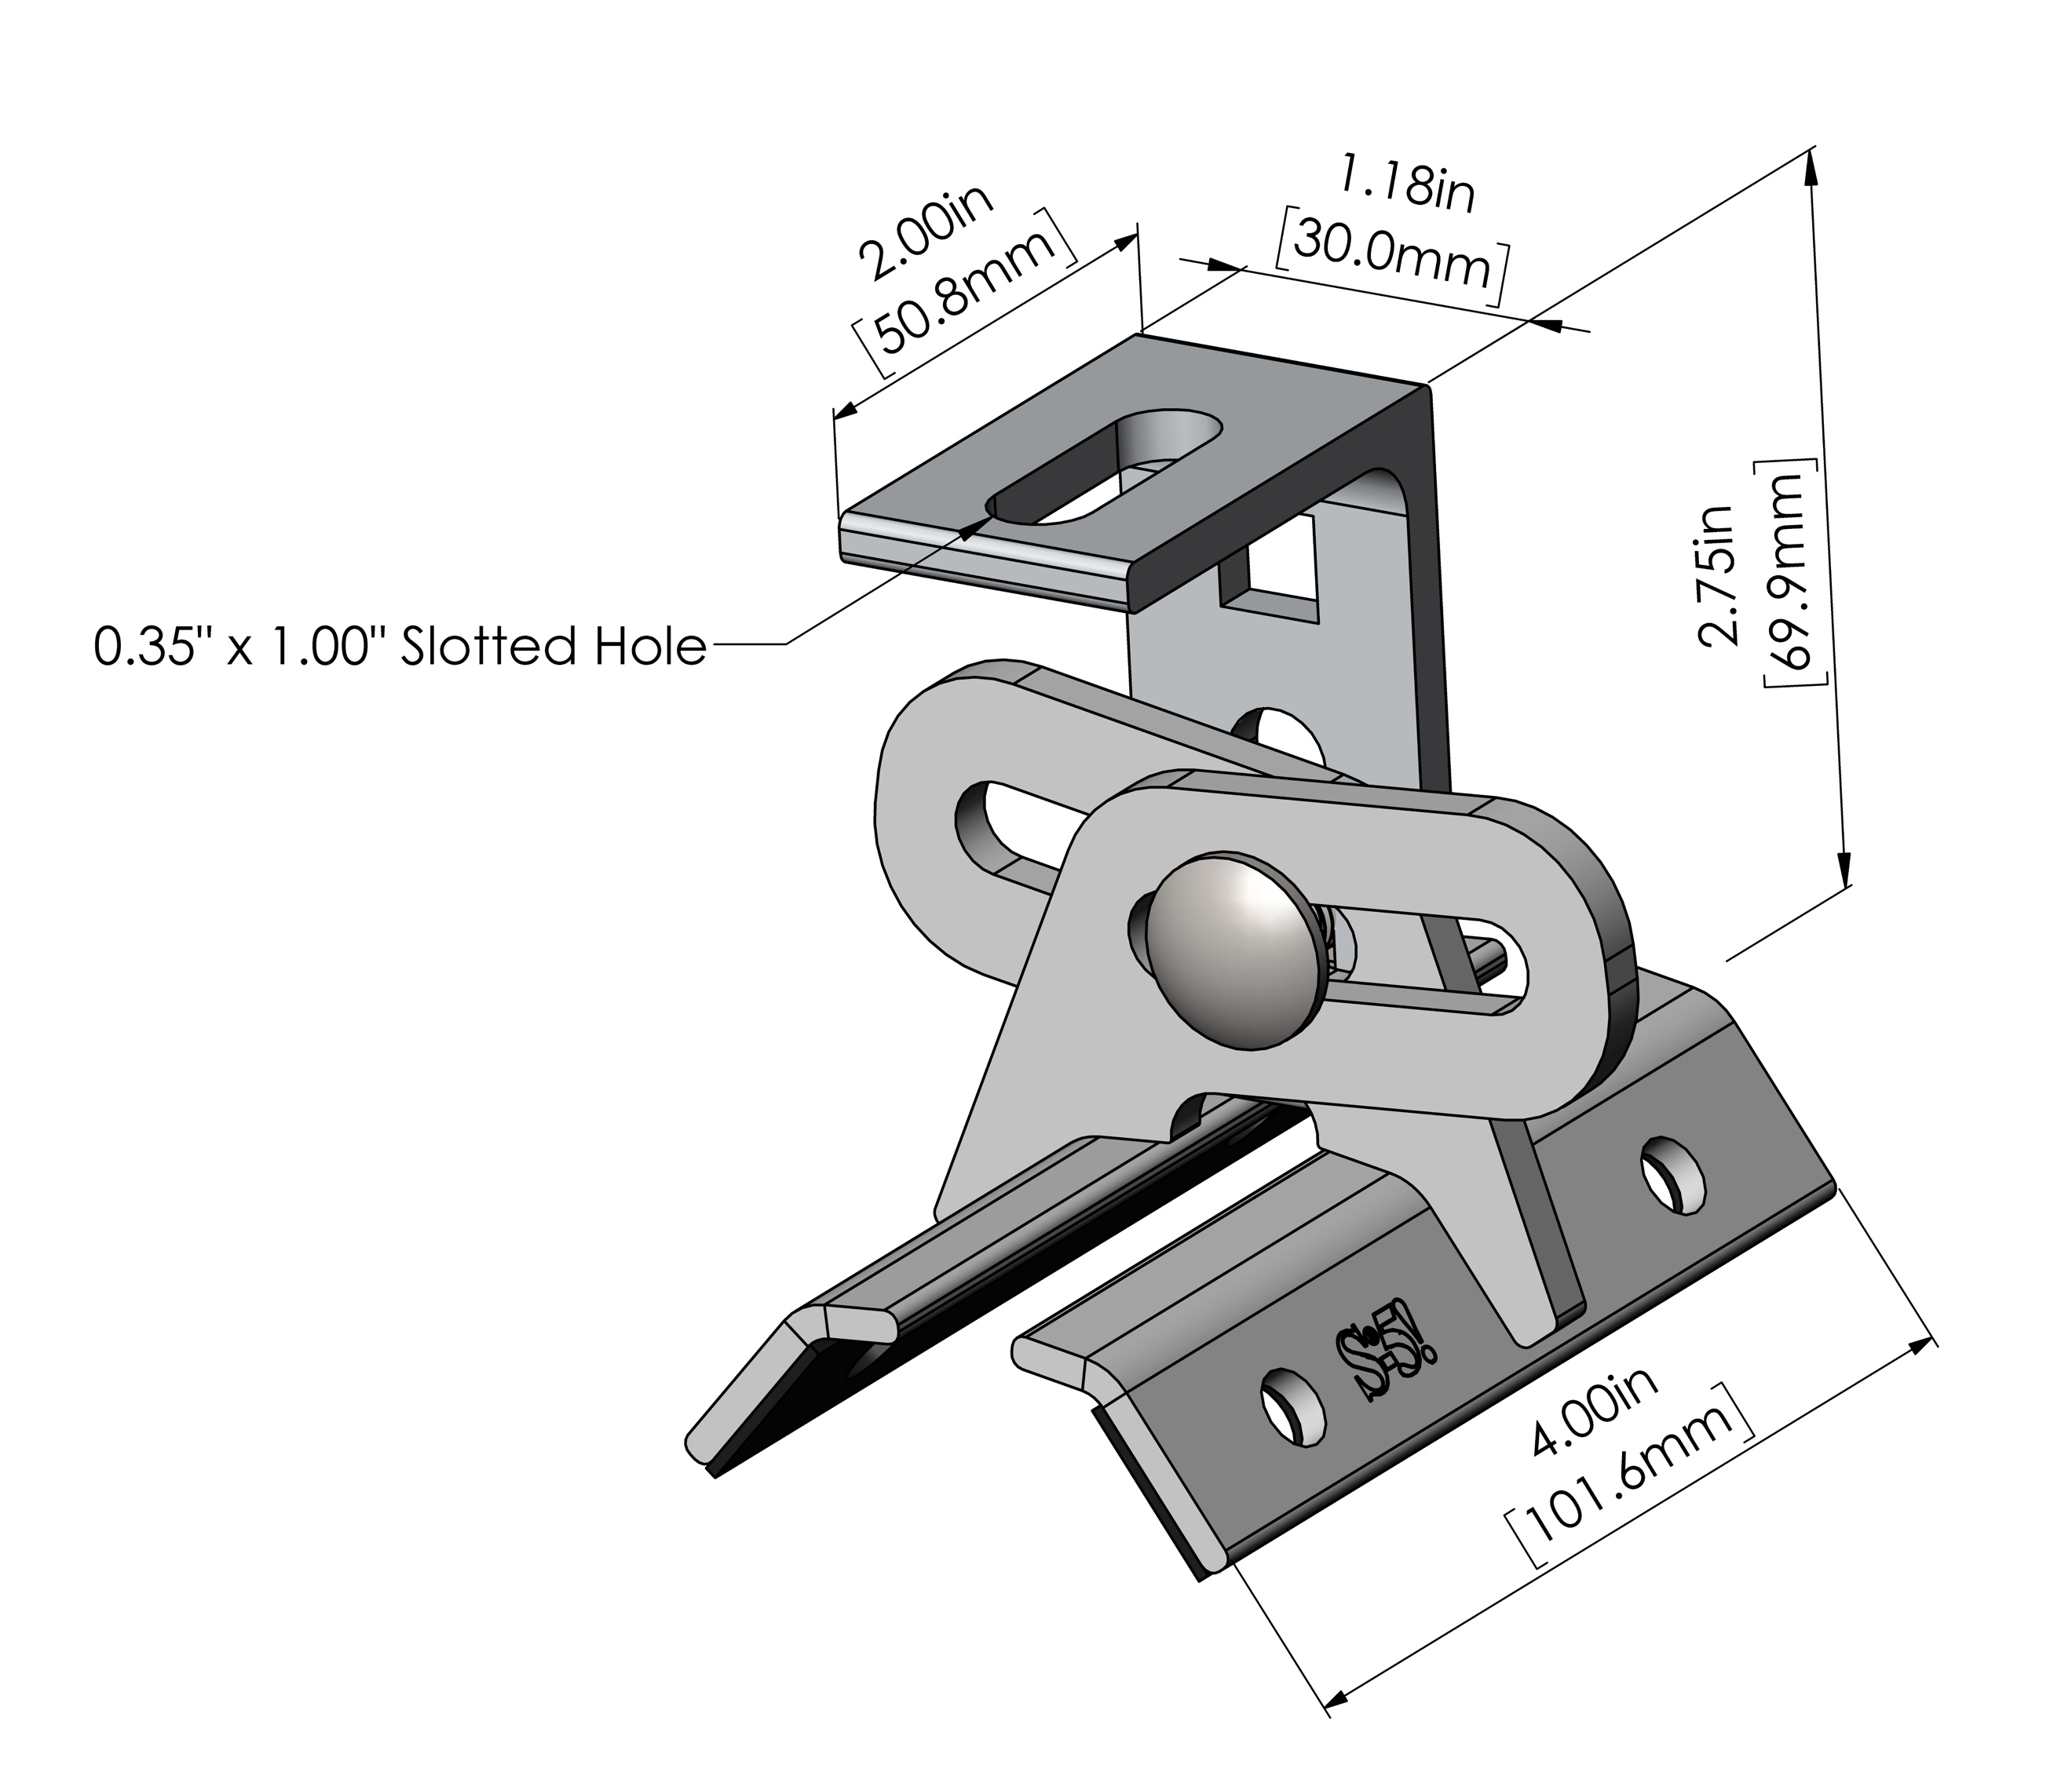
ProteaBracket™ is compatible with common metal roofing materials and comes with a pre-applied EPDM gasket on the base.
Note: All four pre-punched holes must be used to achieve tested strength. Fasteners are provided.

For design assistance, ask your distributor or view our independent lab test data that can be used for load-critical designs and applications at the link below. Also, please visit our website for more information including metallurgical compatibilities and specifications.

The Right Way™ to attach ProteaBracket to exposed fastened metal roofs:
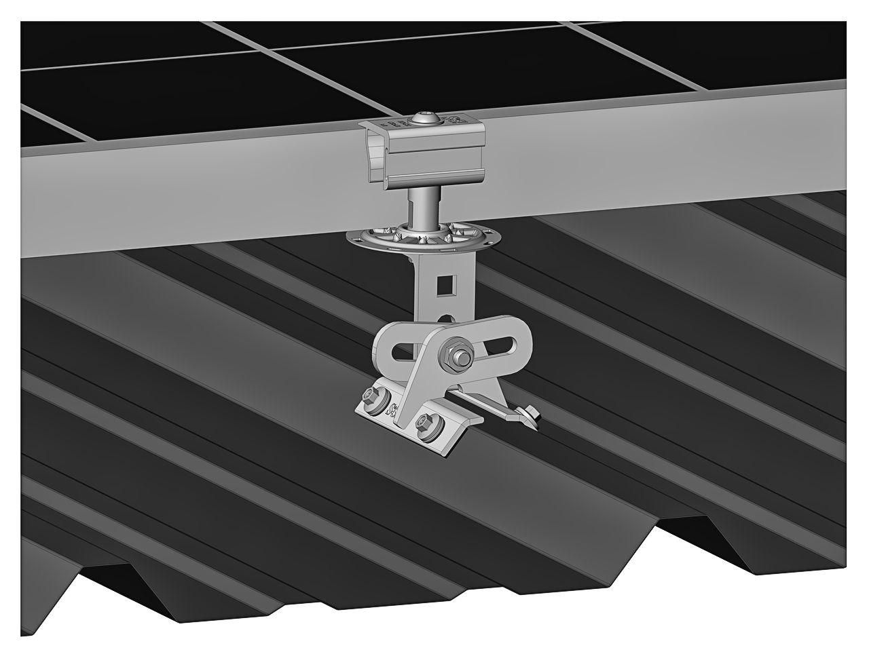
The Right Way, mounted with S-5! PVKIT 2.0.
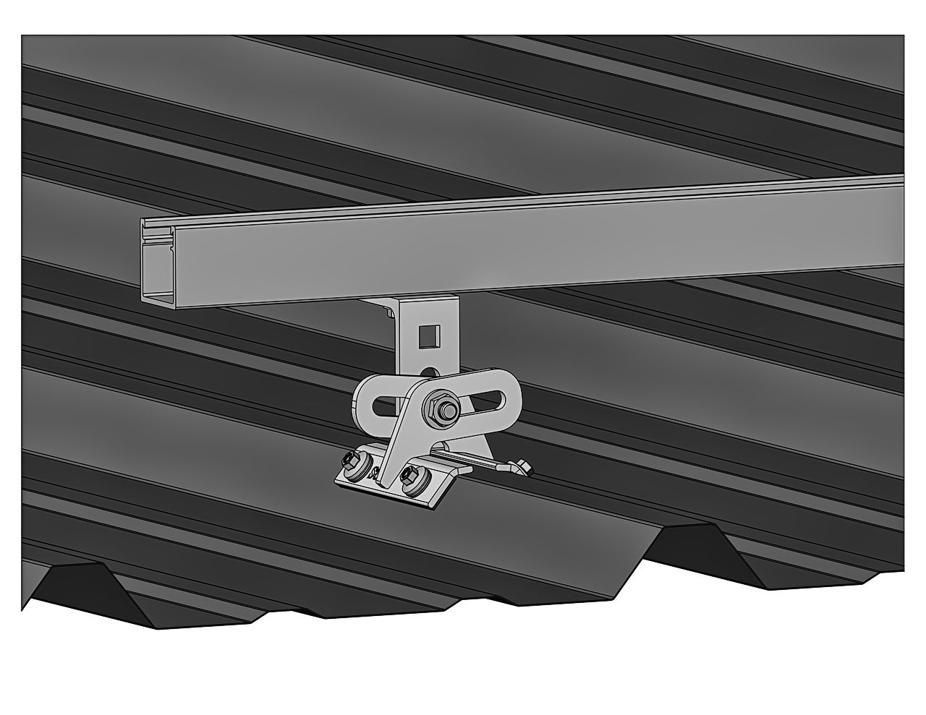
Bottom mount rail
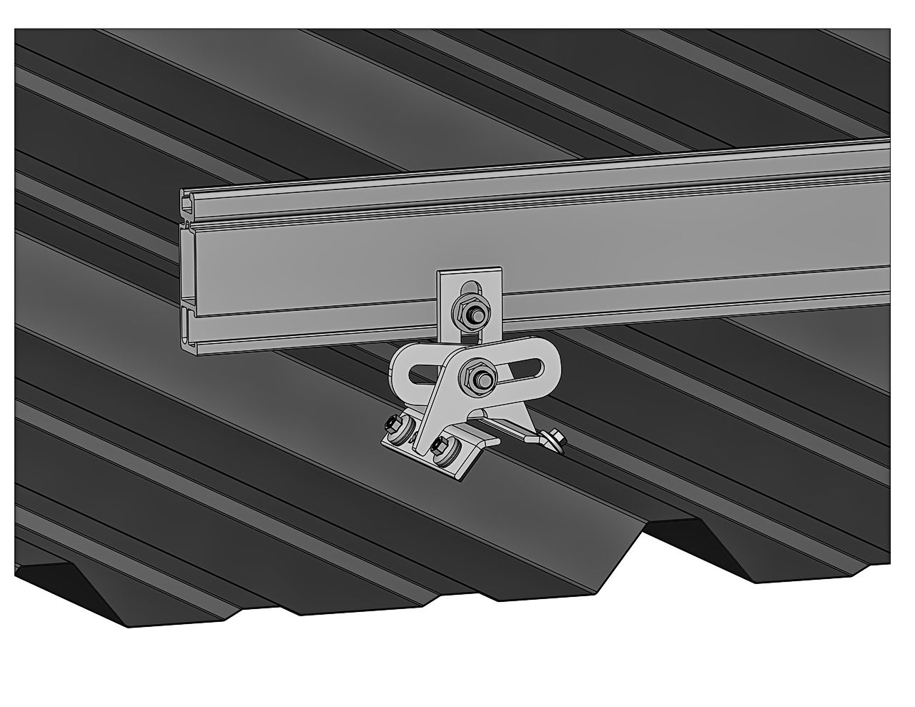
Side mount rail

The WRONG way to attach ProteaBracket to exposed fastened metal roofs:

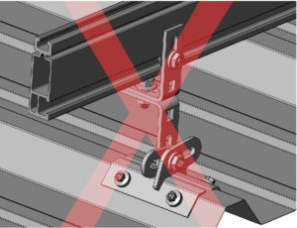
Side mount rail with two L-Foot

S-5! 25-Year Manufacturer’s Limited Warranty
Metal Roof Innovations, Ltd (MRIL) warrants that all S-5! products manufactured by it and bearing its name to be free from defects in material and workmanship on the date of sale by an authorized MRIL distributor to the original purchaser. As purchaser’s sole remedy for breach of this warranty, MRIL will, for a period of twenty-five (25) years after the date of sale, repair or replace any part of the S-5! manufactured product which is defective. This warranty applies only when the S-5! product is properly installed, used and maintained. Read the full warranty.

