What are the Advantages of a Metal Roof vs. Shingles?

Posted by McElroy Metal ● July 11, 2019

Metal roofing and shingles are two of the most popular residential roofing materials. However, metal roofing offers homeowners a wide range of advantages when compared with shingles. So, what are the advantages of a metal roof versus shingles?

Longevity and Durability
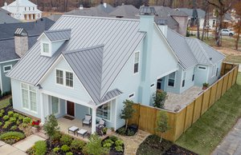
Perhaps the most critical advantage metal roofing offers homeowners is longevity.
Roofing can often be one of the most expensive purchases a homeowner will make after the purchase of the home itself. Roof replacement can also be disruptive to home life and is all around a process most homeowners try to avoid. It is unsurprising then that minimizing the number of times the roof of a home will need to be replaced or repaired is a priority for many homeowners.
When comparing longevity between metal roofing and shingles, there really is no contest.
Typical asphalt shingles have an average lifespan of 15 to 20 years. Metal roofing has an average lifespan of 50+ years.
For many homeowners, the first metal roof they install on their home is the last roof they install.
Asphalt shingles are also well known for needing regular maintenance, especially on homes that experience extreme weather like heavy snow, hail, and high winds. Shingle replacement, as well as re-caulking and sealing, are common for residential asphalt roofs.
Metal roofing, on the other hand, is naturally resistant to hail and is one of the best options for high wind areas. Repairs and replacements are also rare for metal roofing.

Energy Efficiency
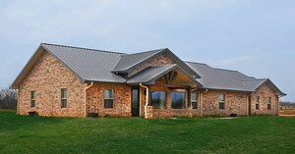
Metal roofing is far more energy efficient than asphalt shingles. Metal roofing offers homeowner’s significant energy savings through the use of cool roof pigments and above sheathing ventilation. Asphalt shingles, on the other hand, absorb heat and trap it in the home, which increases utility consumption.
You can learn more about why metal roofing is energy efficient and how it lowers utility expenses here.

Environmental Impact
Homeowners are becoming more aware of the environmental impact of their roofing, and that’s great. Metal roofing is a fantastic roofing choice for the environment because it is often made from recycled materials and is 100% recyclable at the end of its life!
Asphalt shingles are manufactured from crude oil and chemicals, are typically not recyclable, and can take hundreds of years to decompose in a landfill. Many landfills also charge even to accept shingles because their short lifespan and extensive use means local landfills receive a lot of shingles every year.

Aesthetics
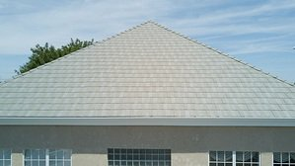
Aesthetics are very personal, and every homeowner is going to have an opinion about what looks best on their home. That being said, even for those who only prefer the look of shingles on a home, there are specialty metal roofing options available that mimic the look of shingles.
In fact, metal roofing comes in a wide variety of both styles and colors/finishes. Shingles, on the other hand, typically only come in a limited number of colors.

Advantages of a Metal Roof versus Shingles
Metal roofing offers significant advantages over shingles in terms of longevity, durability, environmental impact, and aesthetics. The only real advantage of shingles over metal roofing is price.
Asphalt shingles are perhaps the least expensive up-front residential roofing option available today. However, increased repair costs, frequent replacement, and higher utility costs often mean that metal roofing is more economical over time.
Want to see all of the most common residential roofing options compared? Check out this table from the Metal Roofing Alliance that makes comparing all of your options easy!

About McElroy Metal
Since 1963, McElroy Metal has served the construction industry with quality products and excellent customer service. The family-owned components manufacturer is headquartered in Bossier City, La., and has 13 manufacturing facilities across the United States. Quality, service and performance have been the cornerstone of McElroy Metal’s business philosophy and have contributed to the success of the company through the years. As a preferred service provider, these values will continue to be at the forefront of McElroy Metal’s model along with a strong focus on the customer. More information can be found at http://www.mcelroymetal.com.

