Metal Roof Colors and Styles

Posted by McElroy Metal ● June 20, 2019

Metal roofing not only offers performance advantages like a long lifespan and lower utility expenses, but it also provides homeowners a way to enhance their home's curb appeal. With a wide range of metal roof colors and styles to choose from, metal roofing is an excellent way to upgrade the functionality and aesthetics of your home.

Metal Roof Style Options
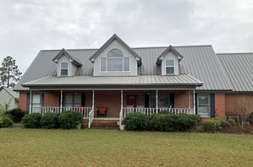
There are a number of metal roofing style options available to residential homeowners ranging from economical exposed fastener systems to specialty roofing styles that simulate shingles, slate, tile and cedar shake. Homeowners will need to weigh cost and performance against aesthetics to select the right roofing system for their home.
Exposed fastener metal roofing systems are the most economical option available to homeowners. Exposed-fastener panels are typically installed over solid decking (or existing shingles and furring strips for re-roof applications) and are attached with fasteners that penetrate through the metal panel and into the roof deck below. Since the fasteners are visible, they are coated in colors that match the metal roofing panels. Concealed fastener standing seam systems are joined together by integral locking seams and are fastened to the deck with fasteners and/or clips that are hidden underneath roofing panels.
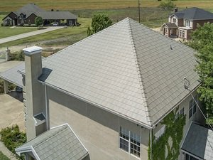
For homeowners who prefer the aesthetics of more traditional roofing materials like shingles or tiles, specialty metal roofing systems are available that mimic the style of other materials with all the benefits of metal.
Metal roofing that looks like shingles, for instance, can mimic the appearance of slate or shake tiles. Met-Tile, on the other hand, look like clay tiles. These metal roofing systems tend to be more expensive, but they can add a lot to the aesthetics of a home and, for homeowners with HOA concerns, specialty metal roofing is often HOA compliant.

Metal Roof Color Options
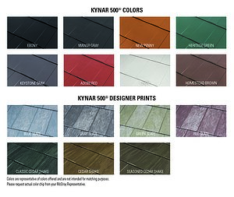
Metal roofing is available in more colors and finishes than most other traditional roofing materials. The most important thing to know about the color of metal roofing is that there are a few types of paint systems available and the best system available is a Kynar 500® (PVDF) paint system.
Kynar 500® paint systems offer superior long-term performance with the best resistance to fade and chalk. Other metal roof paint systems are less expensive up-front but, in general, you get what you pay for. The less expensive the paint system, the greater the potential for fade and chalk.
The specific color and finish options available will be determined by the style of metal roofing you select. You can see a selection of our metal roofing color and style options available here.

Learn More
Need some help selecting a metal roof color and style for your home? Check out our post "How to Choose Metal Roof Color" or contact us at any time to learn more about our roofing solutions.

About McElroy Metal
Since 1963, McElroy Metal has served the construction industry with quality products and excellent customer service. The family-owned components manufacturer is headquartered in Bossier City, La., and has 13 manufacturing facilities across the United States. Quality, service and performance have been the cornerstone of McElroy Metal’s business philosophy and have contributed to the success of the company through the years. As a preferred service provider, these values will continue to be at the forefront of McElroy Metal’s model along with a strong focus on the customer. More information can be found at http://www.mcelroymetal.com.

