What is a Standing Seam Hip Roof?

Posted by McElroy Metal ● June 13, 2019

Standing seam metal roofing is a long-lasting roofing solution that can be used to advantage on both hip and gable roofs.

What are Hip Roofs and Gable Roofs?
A hip, or hipped, roof is a style of roof where each side of the roof slopes downwards toward the walls. The hips of a hip roof are the external angles two adjacent sides create where they meet.
Hipped roofs tend to have fairly gentle slopes, and homes with a hip roof can also have gable portions or dormers.
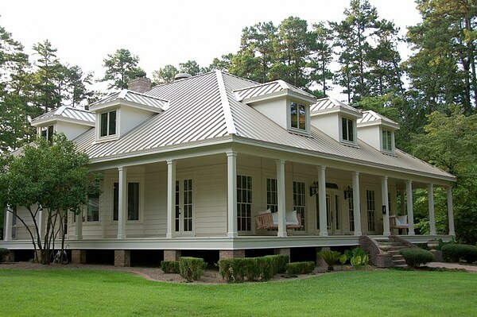
This is an example of a hip roof
A gabled roof, on the other hand, features a roof with two sides that slope downward toward the walls. Walls enclose the ends of gabled roofs, and a gable is itself the portion of the wall between the two roof sides.

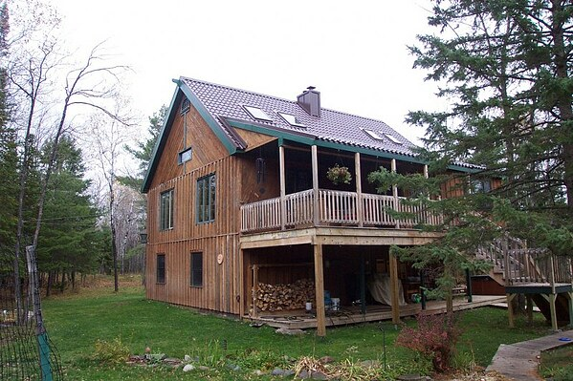
This is an example of a gable roof
Hip roofs, in general, are more complex than a gabled roof and requires rafters or trusses. However, a hip roof is self-bracing and is much better suited to hurricane-prone areas as a result. Gable roofs are less complex and less costly but tend to be plainer and more prone to wind damage.
However, unless a home or structure is very simple, most roofs tend to feature multiple details and can feature both hip and gable roofing.

What is a Standing Seam Roof?
Metal standing seam roofs feature panels, typically vertical panels, that run the length of the roof (from eave to ridge). The panels are either snapped-together or seamed together with a roof seaming machine that joins panels together and creates a watertight roofing surface.
Standing seam roofs are recognizable by the raised vertical seams where adjoining panels connect.
Standing seam roofs can be installed on hip roofs, gable roofs, or roofs with multiple features.

Learn More about Metal Roofing
The best way to maximize your metal roofs durability and longevity is to work with an engineer or qualified distributor/contractor of metal roofing systems. You can find a McElroy Metal Distributor or Contractor here.

About McElroy Metal
Since 1963, McElroy Metal has served the construction industry with quality products and excellent customer service. The family-owned components manufacturer is headquartered in Bossier City, La., and has 13 manufacturing facilities across the United States. Quality, service and performance have been the cornerstone of McElroy Metal’s business philosophy and have contributed to the success of the company through the years. As a preferred service provider, these values will continue to be at the forefront of McElroy Metal’s model along with a strong focus on the customer. More information can be found at http://www.mcelroymetal.com.

