Residential Standing Seam Metal Roof

Posted by McElroy Metal ● June 11, 2019

Residential standing seam metal roofs are an affordable metal roofing option with an attractive appearance and many colors and styles to choose from.

What are Standing Seam Roofing Systems?
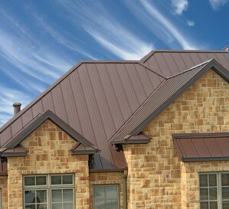
Perhaps the most recognizable of the metal roofing styles on the market today, standing seam metal roofing systems connect adjoining panels with a raised interlocking seam. The raised seam where panels connect gives standing seam systems their distinctive appearance.
Typically installed vertically, standing seam systems most often run from eave to ridge. Standing seam systems are installed with hidden clips and/or fasteners.

Advantages of Residential Standing Seam Metal Roofing
Standing seam systems have all of the benefits of metal roofing. A 50+ year lifespan and decreased utility costs from increased energy efficiency are two of the most critical advantages of metal roofing.
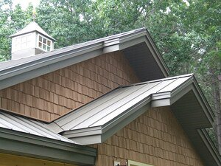
For homeowners in high wind prone areas, metal roofing can offer a wind resistant roofing solution. Metal roofing is also naturally fire and hail resistant.
Residential standing seam systems are also available in a wide range of colors and finishes, which gives homeowners a great degree of flexibility to match the aesthetics of the home.
Installation with hidden clips and fasteners also helps make standing seam roofing less prone to leaking. Concealed fasteners contribute directly to a longer lifespan because when exposed fasteners are used, they penetrate the surface of the roof, which may decrease the lifespan of the panel and increase the risk of leaking. The lack of visible fasteners is also more visually appealing.
Standing seam systems also tend to be one of the more affordable metal roofing systems.

Learn More
Standing seam metal roofs offer homeowners all the advantages of a metal roof with a wide range of design options to choose from. Check out our standing seam metal roofing options or contact us to learn more about all of our residential standing seam metal roofing systems.

About McElroy Metal
Since 1963, McElroy Metal has served the construction industry with quality products and excellent customer service. The family-owned components manufacturer is headquartered in Bossier City, La., and has 13 manufacturing facilities across the United States. Quality, service and performance have been the cornerstone of McElroy Metal’s business philosophy and have contributed to the success of the company through the years. As a preferred service provider, these values will continue to be at the forefront of McElroy Metal’s model along with a strong focus on the customer. More information can be found at http://www.mcelroymetal.com.

