How to Measure a Roof for Metal Roofing

Posted by McElroy Metal ● July 02, 2019
Most residential homes don’t have a perfectly square roof, which is fine, but it can make measuring a roof for metal roofing a bit tricky. Most home roofs also have a pitch and angles that need to be taken into consideration when measuring which can also make things complicated. Not too worry though, we put together some of our best tips and tricks for how to measure a roof for metal roofing.

The Basics: What You Need to Measure
The very first thing to do when measuring your roof for metal roofing is to draw out a top-down drawing of your roof. This drawing doesn’t have to be perfect, but it does need to clearly label all of the features of the roof in inches and feet.
You should also include any porches or overhangs that are attached to your roof that will need to be covered in your new metal roofing.
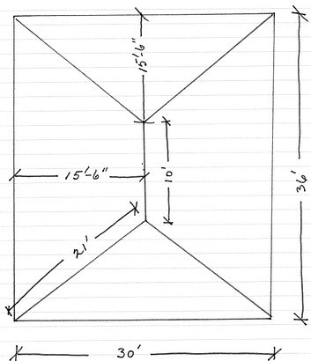
Your drawing can be as simple as a sketch on notebook paper
Measuring your roof slopes and including them in your drawing can be helpful, but they aren’t required. Also, if you find that your roof slopes are lower than what is recommended for the panel system, McElroy can recommend alternative panel choices that fit your project needs.

Don’t Forget to Include Chimneys and Skylights
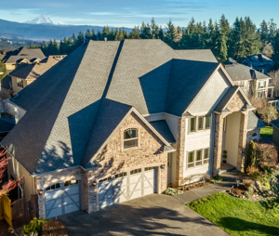
There are a couple of things you will also need to label and measure beyond the basics like any porches that might be attached to your main roof.
Anything that protrudes from your roof should be taken into account. This could be a chimney or piping, but a good rule of thumb is to measure the dimensions of anything that protrudes from the roof.
Also, don’t forget about skylights or other recessed areas.
Basically, anything that breaks up the smooth plane of the roof should be added to your drawing and labeled with measurements.

Tips and Tricks
Don’t measure to the edge of the shingles. The roof deck dimensions are what is important. Measuring this way means you can accurately consider the pull-back and overhang of the new panels.
Also, order the hip and valley panels a little bit longer than you think you need them (6” to 12”). A little extra material will go a long way if conditions are different during installation.

About McElroy Metal
Since 1963, McElroy Metal has served the construction industry with quality products and excellent customer service. The family-owned components manufacturer is headquartered in Bossier City, La., and has 13 manufacturing facilities across the United States. Quality, service and performance have been the cornerstone of McElroy Metal’s business philosophy and have contributed to the success of the company through the years. As a preferred service provider, these values will continue to be at the forefront of McElroy Metal’s model along with a strong focus on the customer. More information can be found at http://www.mcelroymetal.com.

