Touch-up Paint Tips

Quickly and correctly apply touch-up paint to metal panel scratches

By Mark Robins, Senior Editor, Metal Construction News
Posted February 27, 2017

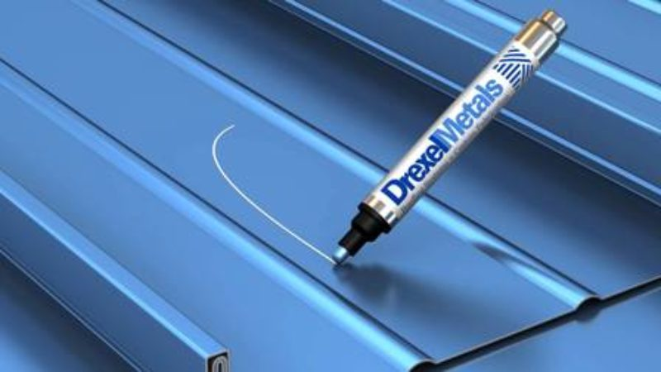
All painted metal panels have a factory-applied, baked-on finish. While these paint coatings are durable, improper handling and installation can mar and damage the finish. Touch-up paint can cover unwanted scratches, chips, abrasion marks or other lightly damaged areas on the panel to present a consistent finish and appearance.
A finished paint layer on a metal panel is no thicker than cellophane; it's easy to see how scratches can occur. Small, slight blemishes do not need to be painted unless they are visually unacceptable. But a deep scratch can compromise the integrity of the paint and the galvanized coating on the panels. If deep scratches are not repainted, water will gather in the uneven surface and corrosion and rusting will occur. Touch-up paint is not intended for large areas or deep gouges. "In many cases, the best option may be to replace the panels rather than touch up," advises Scott W. Moffatt, architectural sales manager of industrial coatings at PPG Industries Inc., Pittsburgh.
"One of the major value propositions that we have when competing against other roofing systems is longevity and life cycle costs," says Brian Partyka, president, Drexel Metals, Louisville, Ky. "The use of a proper touch-up system provides owners with a peace of mind that not only will their buildings look good over a long period but will also provide an additional layer of protection above the substrate."

Before Painting
The area to be painted needs to be clean and dry, and free of dirt, moisture, chalk, wax, grease, oil, residue, mildew and other contaminants. Follow the panel manufacturer's instructions for cleaning. Often, a small of mineral spirits on a clean cloth can do this. Also, "A mild solvent, such as Naptha, and a clean cloth can wipe down the surface," says Nicholas Schneider, North American match sales manager, Valspar Specialty Paints: Precision Color, Valspar Corp., Minneapolis. "Glossy surfaces may need to be dulled using a medium- to fine-grit sandpaper. This will ensure proper adhesion of paint." Perhaps of greater importance is ensuring the touch-up paint is of the same quality and performance as the existing paint on the metal. Schneider says if in doubt consult a trusted paint manufacturer, the original finishing provider or the panel manufacturer.
Touch-up paint can help present a consistent finish and appearance.
"Do not run to a retailer to purchase touchup paint, call your supplier to find out what they recommend," agrees Partyka. "Using the wrong type of paint system will cause future issues for you, your reputation and your customer. The paint systems used in our industry vary from polyesters to siliconized modified polyesters (SMPs) to polyvinylidene fluorides (PVDFs) [like] Kynar/Hylar, and have different chemistries and will react differently than one another. PVDFs are in a similar chemical family as Teflon, which means it's hard to get anything to stick to it for a long period. Using the exact paint system as originally used will provide years of protection. It's also important to explain to the end-customer that there may be a slight gloss variance between the baked-on product and air-dry touch."
One method of touching up factory-applied fluoropolymers is to add an acrylic lacquer additive to the fluoropolymer baking product. "The color match is perfect, but the performance of the touch up is inferior and only equal to the quality of the acrylic lacquer," cautions Moffatt. Understand that factory-applied coatings and air-dry touch-up coatings will never match or weather exactly the same over time. "Since there are different resin qualities and pigments for each system, you can never ensure a perfect solution but there can be a vast improvement in long-term quality if similar performances are matched up properly," Moffatt says.
Schneider advises before actually applying touch-up paint to metal to practice on a piece of metal scrap beforehand. "There is no substitute for experience," he adds. "Follow the instructions of the touch-up paint manufacturer to achieve the proper color and gloss."
There are three application methods for touchup paint: brush-on, spray aerosol and pens. Each has a slightly different procedure.

Application: Brush-on
According to Valspar, the following procedures should be used when applying brush-on touch-up paint.
1. Always shake the tightly capped bottle for at least one minute after the mixing balls begin to rattle. If the product is not adequately mixed, the color of the paint will not be correct.
2. Dip the brush into the bottle as far as it will go.
3. Slowly remove the brush from the bottle.
4. Brush the paint on to the clean, dry surface with smooth strokes. Use very slight pressure when touching the brush to the surface. Avoid retouching the wet paint film with the brush after it is applied. Do not retouch paint after it has set for more than two minutes.
5. When finished, recap the bottle.

Application: Aerosol
According to Valspar, the following procedures should be used when using spray aerosol touch-up paint.
1. Always shake the aerosol can for at least one minute after the mixing balls begin to rattle. If the product is not adequately mixed, the color of the paint will not be correct.
2. When spraying, always hold the can upright 10 to 12 inches from the clean, dry surface. For best results, spray with even misting passes. When a smooth continuous film has been achieved, the paint will have a glare or wet look. Allow the paint to dry five minutes and then continue. Shake the can periodically between coats.
3. When finished, prepare the can for storage. Hold the aerosol can upside down and spray until you see a white gas (usually two to three seconds). This will clear the valve and prevent paint from drying in the spray tip.
Moffat agrees that using multiple light passes to build the film and avoid sagging works best. Also, "Recoat time will vary depending on humidity conditions," he adds. "Do not recoat if the first coat is still wet to the touch or wrinkling/slumping may occur."

Application: Paint
Partyka says paint pens are a lower-cost and more efficient alternative to other touch-up systems. "Paint pens allow contractors to quickly and easily touch-up scratches on the metal panels, saving time, money and future potential problems," he adds. "No waste, no spillage, no brushes and no cleanup." According to Valspar, the following procedures should be used when using a touch-up paint pen.
1. Always shake the tightly capped paint pen for at least one minute after the mixing balls begin to rattle. If the product is not adequately mixed, the color of the paint will not be correct.
2. When using the pen for the first time, remove the cap and prime the tip with paint by pressing it a few times against an inconspicuous horizontal flat surface. This will allow the spring-loaded tip to actuate the valve, causing paint to flow from the pen. Paint will begin to flow through and around the tip. The tip is now primed.
3. Press the tip against the area to be touched-up. Press only when additional paint is required to cover the repair area. Pressing the tip continuously may result in too much paint being dispensed.
4. Apply the paint on to the clean, dry surface with smooth strokes. Use very slight pressure when touching the pen to the surface. Avoid retouching the wet paint film with the pen after it is applied. Do not retouch paint after it has set for more than two minutes.
5. When finished, recap the pen.

Prevent Paint Problems
Always store bottles and aerosol cans upright. Do not store them where the temperature may exceed 120 F. Do not store any touch-up paint at either temperature extreme for prolonged periods. If the color does not match, the bottle, can or pen was not shaken enough; or the production coating may have changed. "The pigments must be mixed thoroughly to achieve the proper color and gloss," says Schneider. "It is possible that the original coating's color has shifted and a new color standard should be submitted for color matching.
If the color appears flat or hazy, humid conditions may exist; or the surface being touched-up may be too hot."
If the surface appears streaky on brush-on or paint pen applications, Schneider says the thickness of the paint film could be uneven. "Apply an additional coat and try to get it as smooth and uniform as possible," he says. "With aerosol can applications, all of the passes have [probably] been made in the same direction. Vary the spray pattern."
After the job is completed, any remaining materials must be disposed of properly and in accordance with local regulations. Check with your local recycling/waste management center on the proper disposal and recycling instructions of the touch-up paint application device. Any unused paint can be saved for future use if stored properly in sealed containers.

Recommendations for touching up factory-applied coatings
Original Finish | Air Dry System
PVDF/FEVE Fluoropolymer | PVDF/FEVE
Silicone Modified Polyester/Super Polyester | PVDF/FEVE
Standard Polyester | Acrylic Lacquer
Interior | Acrylic Lacquer
Information supplied by PPG Industries Inc.

