Posted by McElroy Metal ● May 07, 2019

Types of Metal Roofing
Advantages like 50+ year lifespan, durability, and energy savings often have homeowners considering a metal roof when it comes time for a replacement. As residential metal roofing gains in popularity more and more homeowners are interested in the different styles and types of metal roofing that are available. So, let’s break down three popular types of metal roofing.

Exposed Fastener Panels
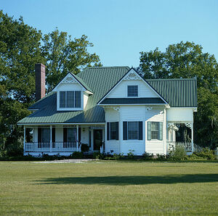
For budget-conscious homeowners looking to get all the benefits of metal roofing, exposed fastener panels are an excellent option.
The most economical metal roofing, exposed fastener panels are typically installed over solid decking and are attached with fasteners that penetrate through the metal panel into the structure below.
Exposed fastener panels come in a wide range of styles and colors, and the fasters are painted with the same paint as the panel, so they are less apparent.
You can learn more about both exposed and concealed fastener panels here.

Standing Seam Systems
Standing seam roofing systems are versatile and can be used for a range of applications, both residential and commercial.
Standing seam systems are made up of panels connected by interlocking seams. Typically installed vertically and run from eave to ridge, their installation style and raised interlocking seams give them a distinct appearance.
Like exposed fastener panels, standing seams systems are also available in a number of colors and finishes.

Specialty Roofing Panels
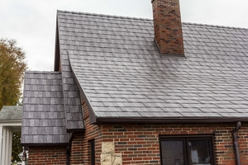
For homeowners who want all of the benefits of a metal roof without the traditional metal roof appearance of a standing seam or exposed fastener system, there are a couple of specialty metal roofing panel options.
Specialty roofing panels are designed to mimic more traditional roofing materials like ceramic tile, slate, shake or shingles without sacrificing the metal roofing advantages.
These systems come in a wide range of colors and finishes so homeowners can pare the more traditional shape of a tile or shingle with whatever color selection best suits their home.

About McElroy Metal
Since 1963, McElroy Metal has served the construction industry with quality products and excellent customer service. The family-owned components manufacturer is headquartered in Bossier City, La., and has 13 manufacturing facilities across the United States. Quality, service and performance have been the cornerstone of McElroy Metal’s business philosophy and have contributed to the success of the company through the years. As a preferred service provider, these values will continue to be at the forefront of McElroy Metal’s model along with a strong focus on the customer. More information can be found at http://www.mcelroymetal.com.

