Posted by McElroy Metal ● May 15, 2019

Metal Roofing Styles
A roof is an essential part of a home’s aesthetic appeal. Metal roofing style and color options can complement the structure, draw the eye, and add that much sought-after curb appeal. Standing seam, metal shingles, and metal tiles are three common metal roofing styles that give homeowners a lot of options and aesthetic flexibility with all the benefits of a metal roof.

Exposed Fastener Panels
Exposed fastener panel systems offer homeowners the most economical metal roofing option as they tend to be the most affordable.
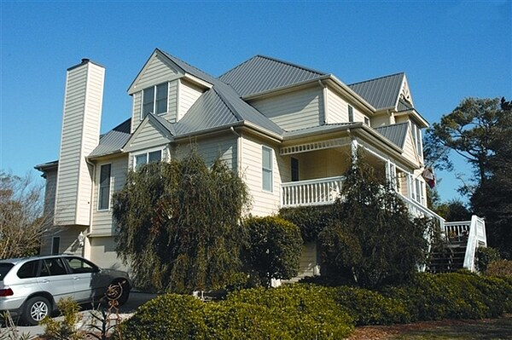
This style of metal roofing comes in a wide variety of styles, colors, and finishes so finding the right system will depend on the individual homeowner's needs including desired longevity, aesthetic appeal, and budget.

Standing Seam Systems
Standing seam metal roofing systems are probably the most recognizable of the metal roofing styles. Featuring interlocking seams that connect panels, standing seam systems have a distinct, attractive appearance.
Standing seam systems tend to be an affordable metal roofing style and come in the widest range of colors and finishes.

Milan Steel Shingles
Milan steel shingles give the appearance of shingles, slate or shake depending on the style, and come in a wide range of color and finish options.
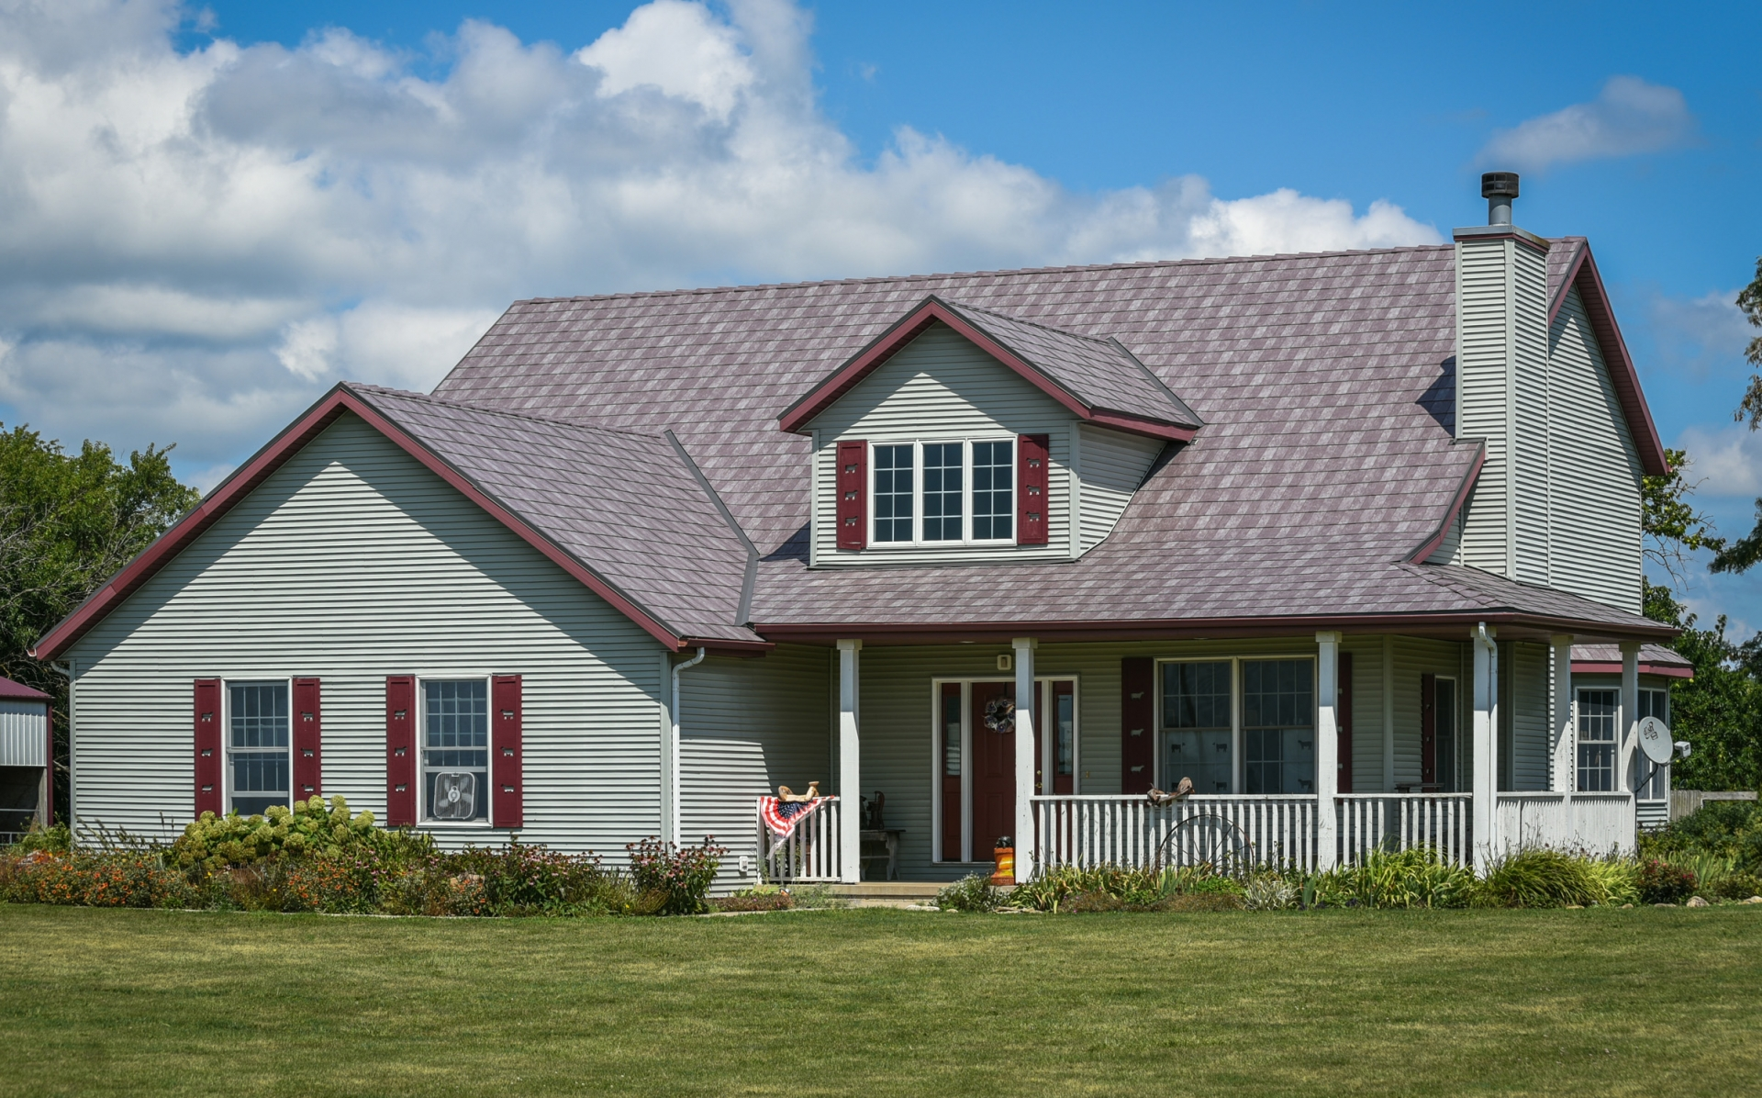
For homeowners whose HOA doesn’t allow vertical seam panels, Milan steel shingles have a more traditional look that complies with regulations while retaining all the benefits of a metal roof.

Met-Tile
Met-Tile is a high performing, panelized roofing system that mimics the look of ceramic tiles. Rather than the individual tiles of a traditional tile roof, Met-Tile comes as a panel that can cover as much area as 80 individual ceramic tiles. This makes Met-Tile much faster to install.
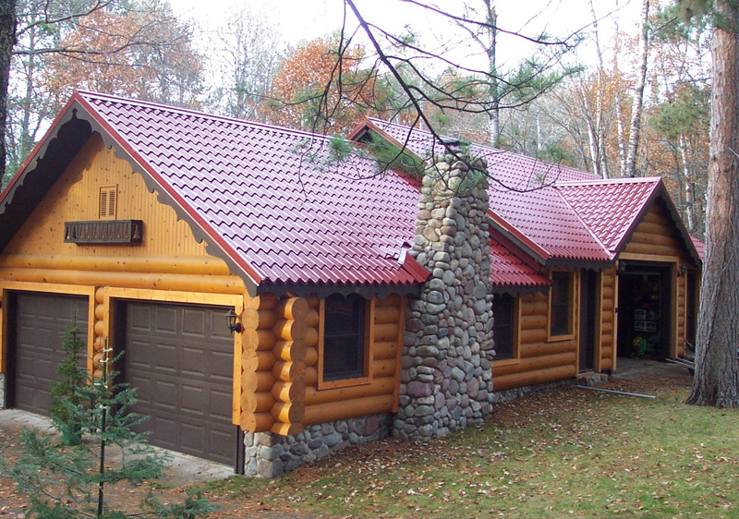
Met-Tile is also a fraction of the weight of ceramic tiles, which helps keep down transportation costs and is advantageous in wind prone areas.
With a wide selection of fade and chalk resistant PVDF (Kynar 500) colors to choose from, Met-Tile will complement the look of any home.

About McElroy Metal
Since 1963, McElroy Metal has served the construction industry with quality products and excellent customer service. The family-owned components manufacturer is headquartered in Bossier City, La., and has 13 manufacturing facilities across the United States. Quality, service and performance have been the cornerstone of McElroy Metal’s business philosophy and have contributed to the success of the company through the years. As a preferred service provider, these values will continue to be at the forefront of McElroy Metal’s model along with a strong focus on the customer. More information can be found at http://www.mcelroymetal.com.

