Posted by McElroy Metal ● May 07, 2019

How to Walk on Metal Roofs
While it is best to avoid walking on your homes roof for purely safety reasons sometimes it can be necessary for your roofing contractor or other trades to access and walk on your roof. So, let’s address some of the most common metal roof access questions.

Can You Walk on a Metal Roof?
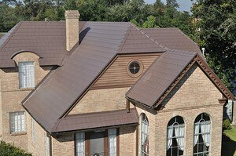
One of the metal roofing myths we’ve come across is the idea that you can’t walk across a metal roof. This rumor might have come from some of the other roofing materials that it is best to avoid walking on. Concrete or clay roofing tiles, for instance, can be damaged if walked across while asphalt can be prematurely worn out with any significant foot traffic. Metal roofing, however, doesn’t suffer from these limitations.
Metal roofing can be walked but, homeowners should refrain from doing so for safety reasons.

If a contractor does need to walk your roof, they should practice sound safety procedures and follow OSHA safety requirements.

Can You Damage a Metal Roof by Walking on it?
Most metal roofs are manufactured and installed in such a way as to be safe to walk across without the worry of damaging the roof. You might mark or scuff the finish or paint on your metal roof, but average foot traffic shouldn’t significantly impact the longevity or performance of your metal roof.

How to Walk on Metal Roof Tiles
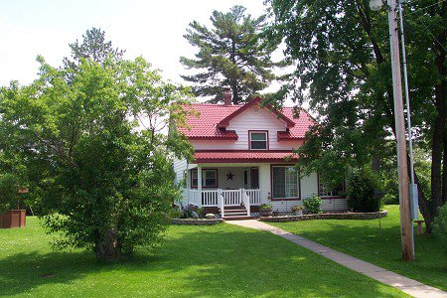
How to walk on metal roof tiles is going to be dependent on the type of roof system and how it is installed. The single best piece of advice for walking on metal roofing is to check with the manufacturer of the roofing product. These resources will be your best source for specific information and warnings about your particular roof.

That being said, in general, the best method is to walk on the areas of the roof that are closest to the decking, trying to avoid ribs or laps. This should help you avoid inadvertently damaging the roof tiles or panels.

To avoid damaging the finish on your roof, your contractor should consider wearing rubber-soled shoes and be careful not to grind debris into the finish.
If access can be obtained via the underside of your roof, through an attic or crawl space, you can visually check that the rafters are sound. While walking on the roof, if possible, contractors should stick to walking on the rafters and avoid any seams in your roofing panels.

General roof and ladder safety should be kept in mind as well, and always follow OSHA safety guidelines.

About McElroy Metal
Since 1963, McElroy Metal has served the construction industry with quality products and excellent customer service. The family-owned components manufacturer is headquartered in Bossier City, La., and has 13 manufacturing facilities across the United States. Quality, service and performance have been the cornerstone of McElroy Metal’s business philosophy and have contributed to the success of the company through the years. As a preferred service provider, these values will continue to be at the forefront of McElroy Metal’s model along with a strong focus on the customer. More information can be found at http://www.mcelroymetal.com.

