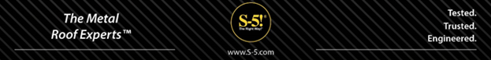

Canadian Equestrian Multi-Purpose Barn – Case Study

The Project
Bruce Goode, a retired cattle-ranch owner and airline pilot, recently downsized and purchased a small 8-acre equestrian estate with spectacular mountain and lake views of the Okanagan Valley area of British Columbia, Canada. The property features a new 3,500-square-foot, multi-purpose barn with a 24-gauge Cascadia Metals Black SMP Standing Seam Metal Roof.

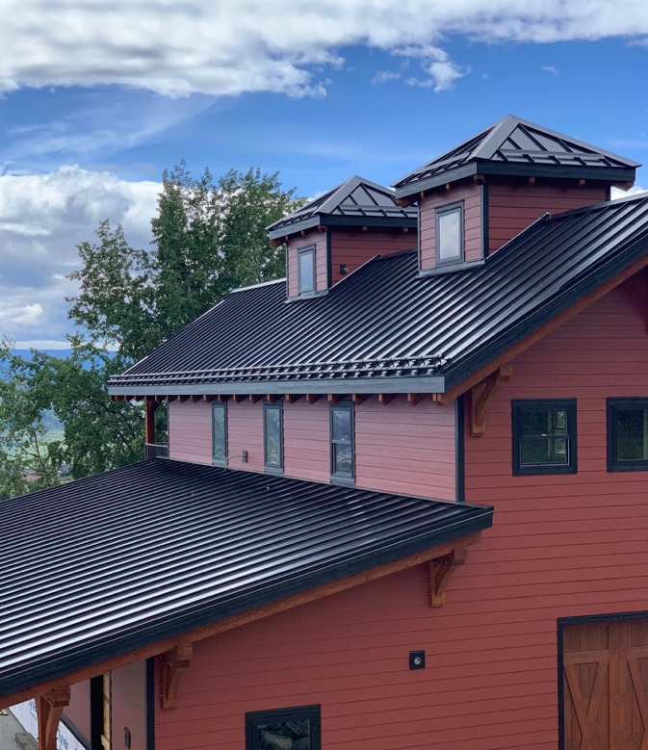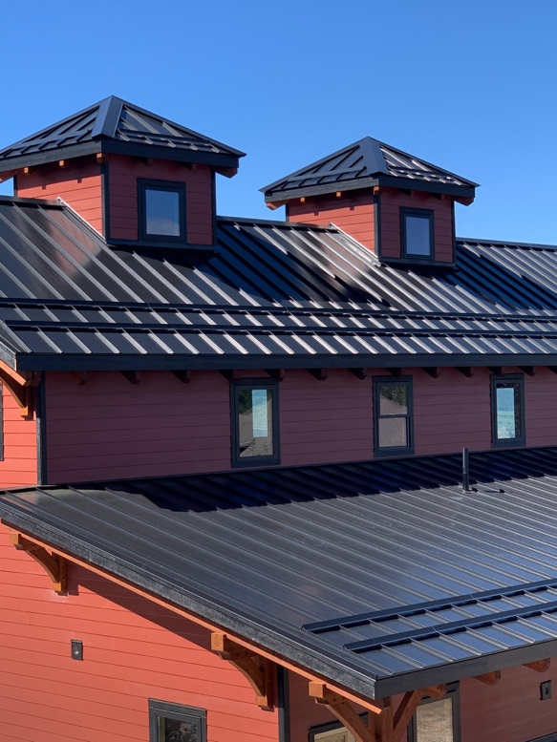

The spacious main floor will be used as a workshop area with a tack room and riders’ lounge. The upper floor open loft area will be used as a “hunting lodge/cowboy shack” themed retreat and entertainment area complete with taxidermy mounts, in addition to a hobby/work area for gunsmithing and another area for exercising.

The Challenge
The owner’s goal was to construct a multi-purpose building that would also serve as a mounting platform for a 28.35 Kilowatt PV solar system, which would provide 100% of the electricity needs for the entire equestrian ranch property. He also needed a roof that would meet the expected 25-30+ year service life of the PV system. Because the barn is located in the northern hemisphere, he needed to orient the roof and the solar panels for maximum solar gain.

Additionally, the property is located within a forest interface area, so a building constructed of fire-resistant materials was preferable. Furthermore, he wanted to reduce the risk of sudden and unexpected release of snow on his new slick metal roof, potentially posing a serious threat to property and visiting guests below.

The Solution
The owner specified a standing seam metal roof for its sustainability and durability, since it is the only roof type with a service life that actually exceeds the service life of a solar PV system. This enables him to avoid potential costly disassembly of the PV array, re-roofing and re-assembly further down the road.

The ridge line of the barn roof was oriented exactly due east/west, to afford maximum solar gain for the 90 solar panel system mounted on the south-facing upper roof and lower roof surfaces.
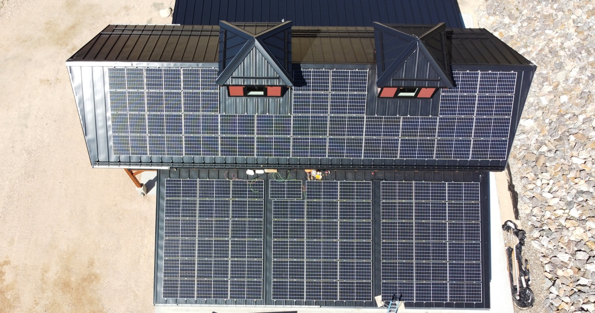
The S-5-PVKIT® 2.0 solar solution (in black to match the black anodized PV frames) enabled solar installers to direct-attach PV modules to the standing seams, eliminating the need for a traditional rail mounting system and provided a simple, secure, economical and penetration-free method for attaching the solar modules.
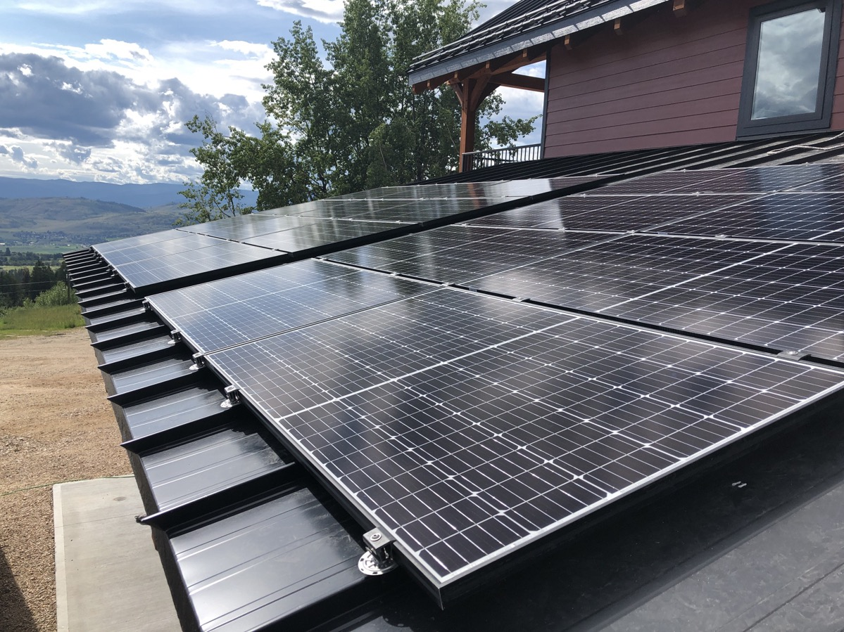
Additionally, in the event of a nearby wildfire, a metal roof was chosen for its non-flammable, non-combustible properties, since it will not spark and ignite into flames during a wildfire or lightning strike, which also helps the owner save on insurance premiums.
S-5!’s X-Gard™ 2.0 snow retention pipe system was selected for its compatibility with the project's standing seam metal roof, providing a penetration free snow retention solution.

“Our multipurpose barn was designed and constructed to withstand time and elements in a challenging western Canadian environment. The barn was built with the exclusive use of durable, weatherproof, fireproof and low-maintenance materials. To maximize the longevity potential of the barn's roof, we chose a standing seam metal roof, which achieved our sustainability goals. The metal roof is performing exceedingly well, easily withstanding the heavy snow loads expected in British Columbia, and it provides an excellent platform for mounting the 90 solar panels, which are directly attached using the S-5-PVKIT 2.0 rail-less, solar attachment solution to the entire south-facing surfaces of the roof. I am confident the barn will provide trouble-free enjoyment for our family today and for many generations to come.” – Bruce Goode, Property Owner

"In British Columbia, our public utility offers full credit for any excess energy produced through a net-metering program for grid-tied systems. Essentially, this means our customers can “store” all excess solar energy for use at night or during the winter when solar generation is reduced. This 90-module, high-efficiency array is anticipated to produce more than 30,000 kWh per year and cover 100% of the property’s annual electricity usage. The system has been operational for a little over 5 months now, and to date, the system has outperformed our expectations.” —Stephen Russell, Owner, Roost Solar, Canada

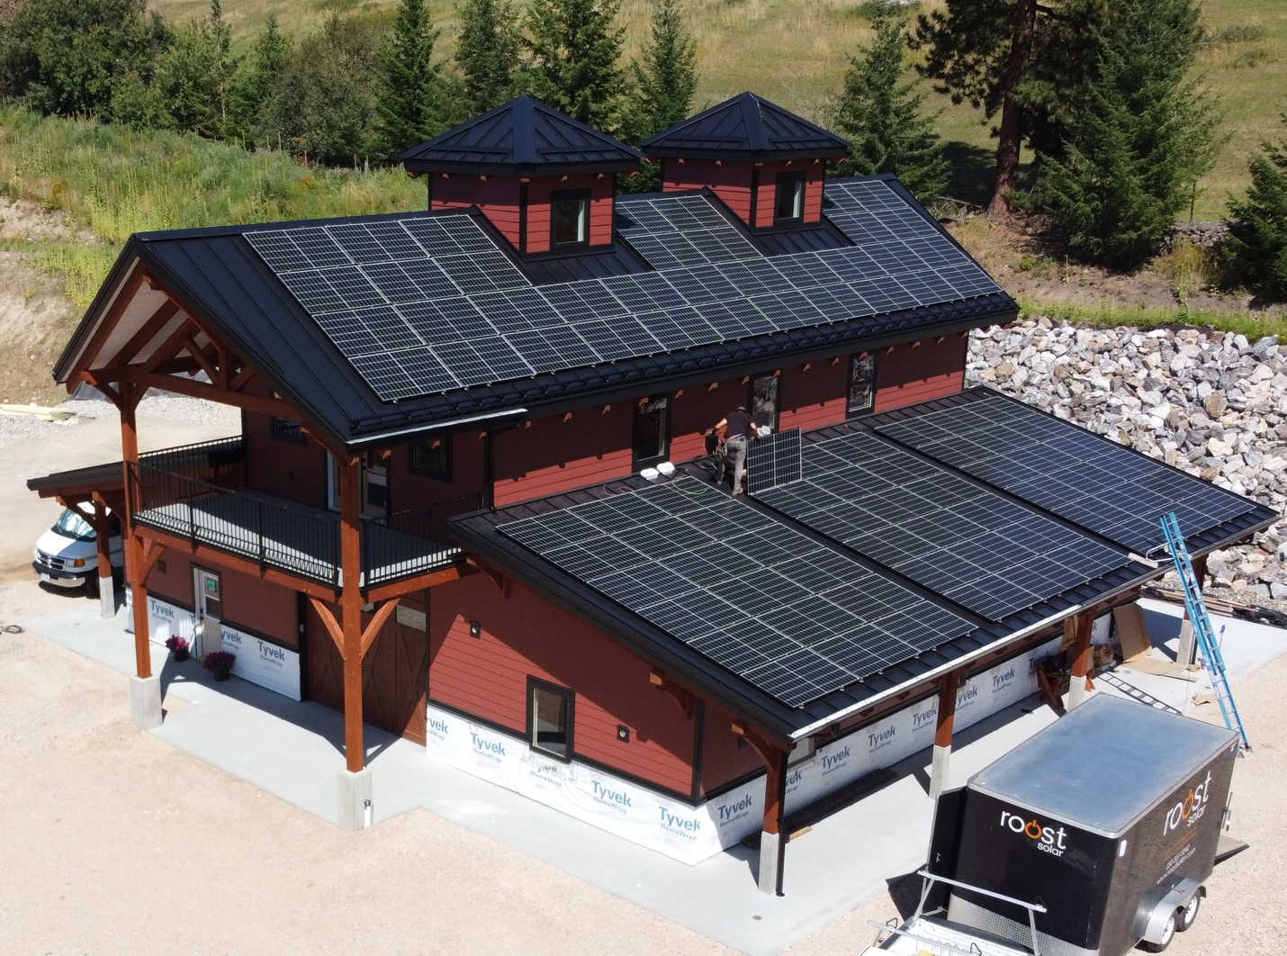

Project Data:
Industry: Residential
Location: Vernon, British Columbia, Canada
Owner: Bruce Goode
Architect: Timber frame engineering and design by Marcus Weiss and Daniel Kilchenmann of European Timberframe Corporation
General Contractor: Woodstyle Homes
Roofing Contractor: Artisan Roofing Ltd.
Roof Profile: 24-gauge Cascadia Metals Black SMP Standing Seam Metal Roof, 20" On Center, 1-1/2" high rib, from New Tech Machinery SSH, SS150
Solar installer: Roost Solar, Inc.
Module Manufacturer: Canadian Solar 315W mono-crystalline modules (CS3K-315MS)
Inverter Manufacturer: 3 SolarEdge HD Wave inverters 7600W each (SE7600H-US) and P340 (340W) optimizers under each panel
Solar & Snow Retention Attachment Manufacturer: S-5!

Project Stats:
- Project Size: 28.35 kilowatts of PV mounted using the S-5-PVKIT® 2.0 solar attachment solution and the S-5-S clamp
- Roof Measured: 6,000 square feet
- Roof Pitch: 8/12 upper roof

About S-5!
Since 1992, S-5! has been the leading authority on metal roof attachment solutions. S-5!’s zero-penetration clamps attach ancillary items to standing seam and conceal-fix metal roofs, while maintaining roof integrity and warranties. S-5! solutions are engineered for a variety of applications: snow retention, fall protection and wind performance systems, satellite dishes, solar arrays, signs/banners, light fixtures, stack/flue bracing, walkways, air conditioning, lightning protection, equipment screens, conduit, condensate lines and more. Made in the U.S.A., S-5!’s products have revolutionized the metal roofing industry and are now installed on more than 2 million metal roofs worldwide, including 2 GW of PV, providing strength and longevity never before seen. For more information, visit www.S-5.com.

###

