The world’s most stunning homes feature metal roofs: The Hope Residence, Palm Springs, California
For a home that is nearly as famous and unique as the American entertainers who inspired it, the Hope Residence in Palm Springs has been compared to a spaceship, a mushroom and a volanco. Whatever shape you imagine it resembles, there is no doubt there is nothing like this nearly 24,000 square foot home set at the highest point overlooking the star-studded city. The most striking element of the curvaceous, expansive home is the roof itself. Made from copper that slopes upward from three points to meet at an enormous open oculus, the roof seems to rise from the mountains, its darked aged patina softly glowing in ever-shifting desert light.
The home, which built in 1979 and designed by famous architect John Lautner who was an apprentice of Frank Lloyd Wright, pays homage to organic shapes, materials and the desert’s natural beauty. That’s why Lautner originally envisioned a dark steel roof for the home, but Delores Hope had different ideas and at one point in its history, the roof was covered in terracotta pink gunite. While not much is known about who eventually restored, installed (and invested heavily) in the gorgeous copper roof that adorns the massive home today, one thing is clear: the metal roof on this architecture masterpiece is the true star of the show.
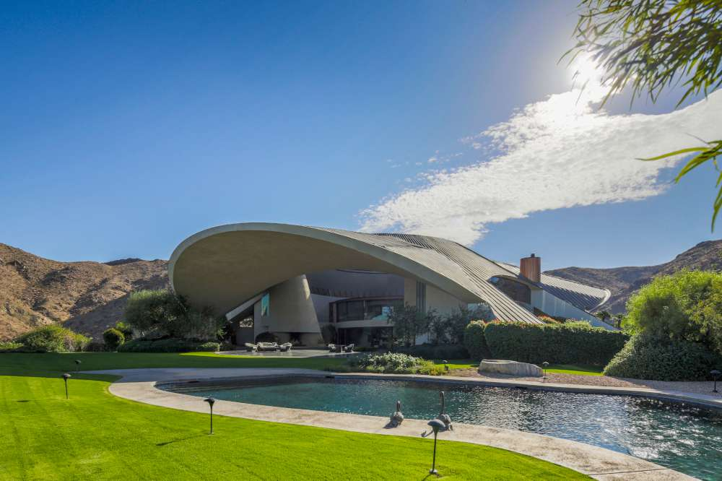
(image source: Zillow)

