Energy-saving All-Star in Tempe

Overview
David, a homeowner in Tempe, Arizona, needed to replace his aging wood shake roof. It had started falling apart, and he wanted to replace it with a more permanent solution. After researching his options, he chose metal shingles because of their longevity, energy-efficiency, and appearance. He found Classic Metal Roofing Systems and connected with Haven Construction, who expertly installed his new roof. The result: a beautiful, lightweight, and durable metal roof that saved 25% on his electric bill.

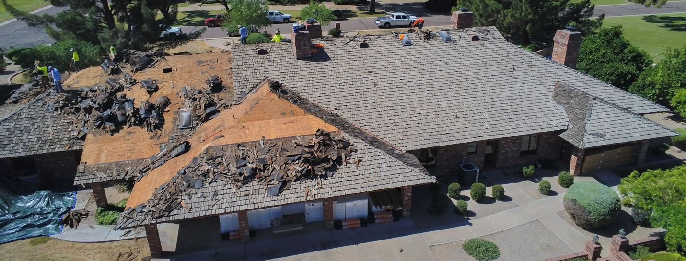

Outcome
David got a Country Manor Shake roof, designed to last a lifetime while providing excellent energy efficiency. The Buckskin color matched the appearance of the old roof but weighs less and will last longer. David had a great experience with Haven Construction and is thrilled with the result.

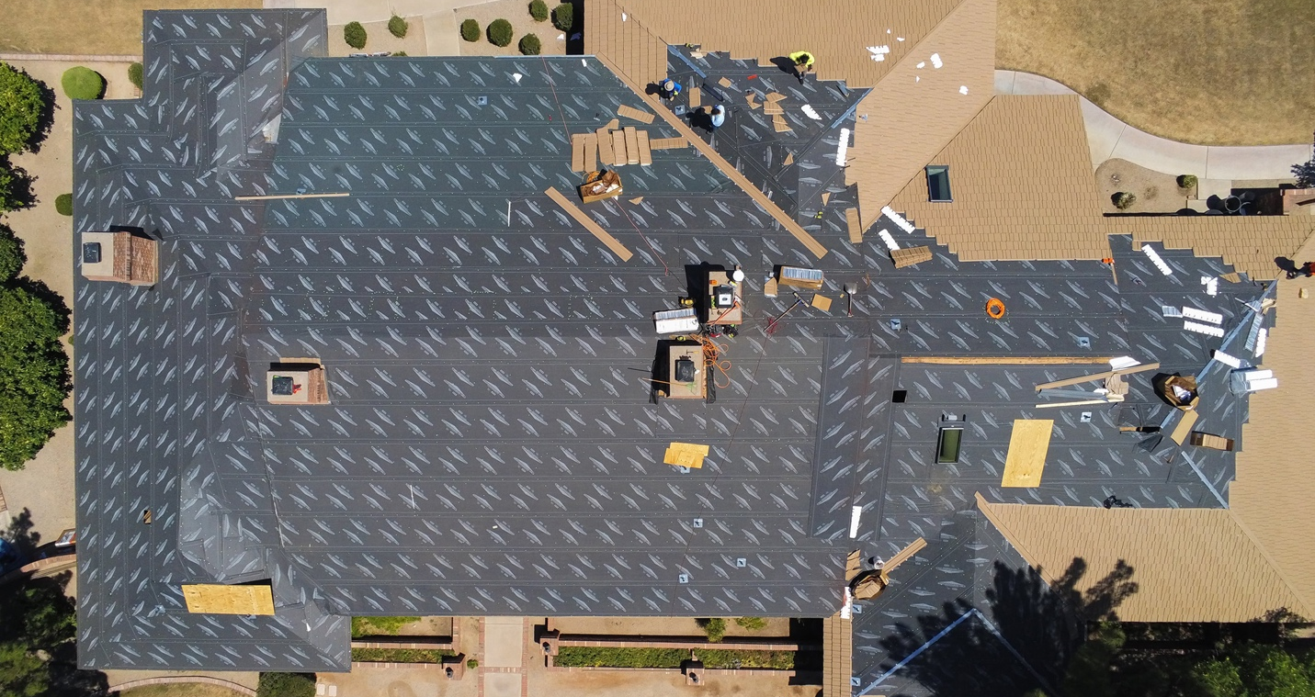

Impact
David’s new roof has saved him 25% on his electric bill, reduced weight on his home, and sheds water better than before. Although David lives in sunny Arizona, he has been able to keep his thermostat higher than before and reduce his electricity usage.

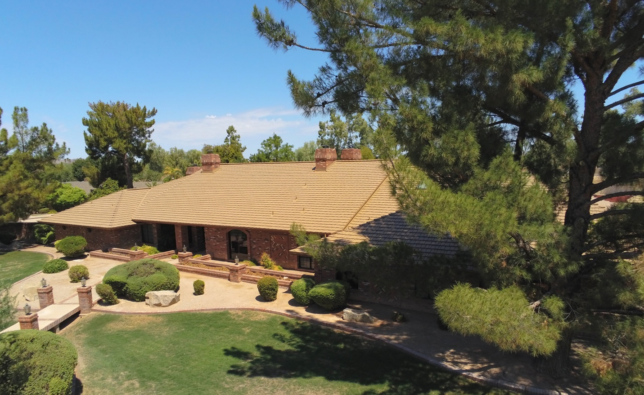

Benefits
- Lifetime Roofing Solution
- Saves 25% on electricity costs
- Matches appearance of the old roof
David started searching for a new roof when his old wood shake roof began to break down. He had tried to patch it, but it was no longer practical. He needed a replacement, but not just any roof. David’s roof is massive, with multiple chimneys and valleys to flash. It covers around 11,500 square feet of space!

David wanted a roof that was durable, attractive, and energy-efficient. He first considered another shake roof but didn’t want to deal with the same issues and eventual replacement. So, he started looking at alternatives to wood shake. His first option was tile, which was too heavy and would damage his house. Also, tiles last for a while, but they aren’t waterproof.

The next option was a metal roof. After learning that metal roofs weigh much less than tile and are much more waterproof, David seriously considered metal roofing. After lots of research, he had narrowed it down to standing seam metal roofing or metal shingles. Standing seam is durable and energy-efficient, but it wasn’t the right look for his house. Metal shingles fit his style better, especially the shake appearance of Country Manor Shake. Now David had met every goal, and his only objection was the cost. After realizing he would make up the extra cost by never replacing his roof again, he was ready.

One significant factor in the purchase was the Lifetime Limited Warranty. Classic’s warranty is non-pro-rated, transferable for 40 years, and covers both materials and labor for repair or replacement. It promises that the shingles can stand up to 120-mph wind, won’t chalk or fade for 30 years, and the coating won’t chip or leak due to hail. This gave David further confidence in Classic and its products.

After David chose Haven Construction, they sent out team members to measure the roof and prepare a quote for the project. After all the materials showed up, the installers got right to work. David said this about his installers, “they showed up bright and early every morning and kept at it every weekday, they were surprisingly good at keeping everything neat and organized, and they left things clean every day. They were very good about taking time to answer our questions and explain their methods. We even got to know the workers, so we were sorry to see them leave once the job was done.”

Country Manor Shake provides many benefits to David, but his favorite is the long lifespan. Knowing he will never need to replace his roof is amazing to him. He’s also received lots of compliments on his new roof. Most people are surprised to learn that it’s a metal roof and not another shake one. However, the most surprising benefit is energy efficiency; his electric bill dropped by 25%!

Contractor’s Perspective
Joe of Haven Construction was in charge of this re-roofing project, and here’s what he had to say about it. “This project had a complex roof, requiring 120 squares of Buckskin Country Manor Shake. The homeowner chose Buckskin to match the appearance of the previous wood shake roof.”

Joe describes his overall experience with Classic as “incredible”. Besides providing Joe with products for the job, he was also equipped with top-of-the-line support. Classic’s president, Todd Miller, answered questions from his installers while they were on the job, Classic sent free parts to help with the project, and the Technical Services team was always available for remote support.

Joe praised the Technical Services team in particular, “the installation manuals had detailed instructions and helpful visuals. We had all of our guys read through them.” Besides the manuals, Classic provided a catalog of YouTube videos to help the installers with specific problems.

Joe also said, “David was a very meticulous customer, who had done his research and was prepared to work with us to find the right solution for his roof. The energy savings David’s seeing are going to continue year after year. He made a great decision in choosing a metal roof from Classic.”

To see a video testimonial of David’s experience, click here.

Haven Construction
2305 South Higley Road
Gilbert, AZ 85295
480-375-5954
havenroofsaz.com

Classic Metal Roofing Systems
8510 Industry Park Dr
Piqua, OH 45365
1-800-543-8938
classicmetalroofingsystems.com

