Hail damage leads to new dream roof
STEEL ROOFING AND SMART INSTALLATION BOOST ENERGY SAVINGS BIG TIME FOR TULSA HOMEOWNERS

The Project:
You wouldn’t expect a 10 year-old house to need a new roof so soon. But such was the case for a Tulsa, Oklahoma homeowner as the result of hail damage to the home’s original asphalt roof. Unfortunately, it’s an issue for many homes since asphalt is particularly prone to hail damage. Large hailstones can puncture or loosen asphalt shingles and can cause severe damage due to leaks and moisture penetration.

The Challenge:
Tulsa experiences a wide range of climate challenges–from hot, muggy summers to cold, windy winters. It is also a high risk for tornados, and obviously hailstorms are a real threat. In light of these regional conditions and the fact that the homeowners already had to replace their roof once, they decided to go with a stronger roof that would last much longer, hold up in severe weather and help save energy no matter what the season. Curb appeal also was a factor, which is why they ultimately chose a Boral Steel® PINE-CREST Shake stone-coated metal roof in a rich charcoal color designed to look just as good as it performs.

Spotlight on MRA member Boral Steel® and NICHTECH Roofing
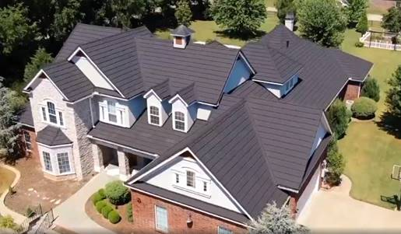
The original asphalt roof was damaged yet still structurally sound, which meant installer NICHTECH could use Boral’s Elevated Batten System® right over the old roof. Doing so not only helps boost energy efficiency and saves on tear-off costs, it also prevents waste. The elevated battens allow for better water flow to prevent potential leaks; providing exceptional peace of mind during Tulsa’s freezing winters when rooftop ice damming can be an issue.

Elevating the battens also adds air space that works to insulate, helping save energy in both hot and cold weather. In fact, the California Building Code recognizes Boral’s system as a cool roof option that meets the minimum 0.85 R value for insulation above the roof deck. Even bare metal is more energy efficient than asphalt, so the choice of quality stone-coated steel along with the elevated batten installation method will allow the homeowners to maximize energy and money savings long-term.

Thanks to this smart, efficient system, NICHTECH was able to install the beautiful new metal roof–nearly 100 squares in all–in just four days. Better yet, the homeowners have a strong, reliable new roof designed to save them a tremendous amount of energy and protect their home for many decades to come.

Thoughts from the Experts: “From high tech, quality metal material to better, more efficient installation methods, this project clearly shows how making the right choices when re-roofing your home can increase performance, durability and value over the long run,” said Renee Ramey, MRA executive director.

For more information, visit Boral Steel® https://www.boralroof.com/product-profile/steel/ and NICHTECH Roofing Co. https://www.nichtechroofsystems.com/
About Metal Roofing Alliance (MRA)
Representing metal roofing manufacturers in the United States and Canada, the Metal Roofing Alliance (MRA) was formed in 1998 to help educate consumers about the many benefits of metal roofs. The main objective of MRA is to increase awareness of the beauty, durability and money-saving advantages of quality metal roofs among homeowners, as well as to provide support for metal roofing businesses and contractors. For more information, visit MRA.

